GAP Production Data Documentation
Bering Sea Survey Team
Gulf of Alaska and Aleutian Island Survey Team
Table of contents

1. Survey Background

1.1 What we do

1.2 Who is conducting the research?
Scientists from the Alaska Fisheries Science Center’s Groundfish Assessment Program (GAP) conduct these bottom trawl surveys with participation from the Alaska Department of Fish & Game (ADF&G), the International Pacific Halibut Commission (IPHC), universities, and other organizations. This research is conducted primarily on chartered fishing vessels.

1.3 What is the research objective?
Learn more about the program. The objectives of these surveys are to:
- monitor the population and environmental trends in the marine ecosystem of the Bering Sea, Aleutian Islands, and Gulf of Alaska,
- produce fishery-independent biomass (weight) and abundance (number) estimates for commercially important fish and crab species, and
- collect other biological and environmental data for use in ecosystem-based fishery management.

1.4 Who is conducting the research?
Scientists from the Alaska Fisheries Science Center conduct these bottom trawl surveys with participation from the Alaska Department of Fish & Game (ADF&G), the International Pacific Halibut Commission (IPHC), and universities. This research is conducted on chartered fishing vessels.

1.5 Bottom trawl surveys and regions
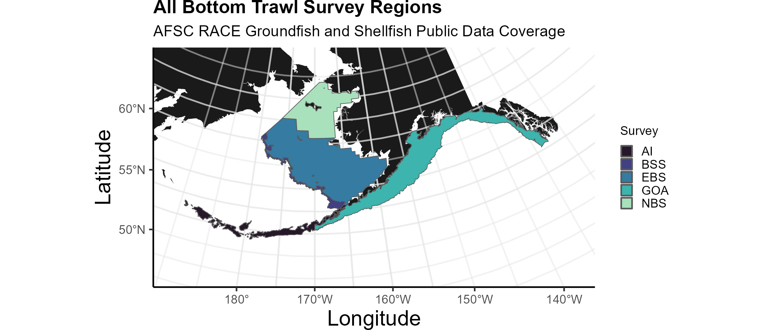
Strata used in the all surveys.
Each survey conducted by the Groundfish Assessment Program are multispecies bottom trawl surveys. We collect environmental and biological data to assess how climate variability and loss of sea ice are affecting bottom-dwelling marine life on the Bering Sea shelf. We monitor trends in the distribution (location and movement patterns) and abundance of groundfish and crab species as well as oceanographic data (e.g., water temperature, depth). We collect biological information such as organism weight, length, stomachs to learn about diets, and otoliths to determine fish ages. We use this information in annual stock assessments and to assess the state of the ecosystem. This research is conducted on fishing industry contract vessels.
Survey | Survey Definition ID | Years | Depth (m) | Area (km2) | # Statistical Areas | # Possible Stations
Aleutian Islands Bottom Trawl Survey | 52 | 2022 - 1991 (13) | 1 - 500 | 64,415.0 | 80 | 1,312
Eastern Bering Sea Slope Bottom Trawl Survey | 78 | 2016 - 2002 (6) | 201 - 1,200 | 32,861.3 | 37
Eastern Bering Sea Crab/Groundfish Bottom Trawl Survey | 98 | 2023 - 1982 (41) | 1 - 200 | 492,989.9 | 28 | 515
Gulf of Alaska Bottom Trawl Survey | 47 | 2023 - 1990 (16) | 1 - 1,000 | 313,784.9 | 37 | 6,939
Northern Bering Sea Crab/Groundfish Survey - Eastern Bering Sea Shelf Survey Extension | 143 | 2023 - 2010 (6) | 1 - 100 | 198,866.8 | 4 | 144

1.5.1 Aleutian Islands
Most recent data report: (Von Szalay et al., 2023)
- Upper Continental Slope of the Aleutian Islands from Unimak Pass to Stalemate Bank
- Triennial (1990s)/Biennial since 2000 in even years, since 1992
- Modified Index-Stratified Random of Successful Stations Survey Design
- Important commercial fish species include Atka mackerel, Pacific ocean perch, walleye pollock, Pacific cod, sablefish, and other rockfish species.
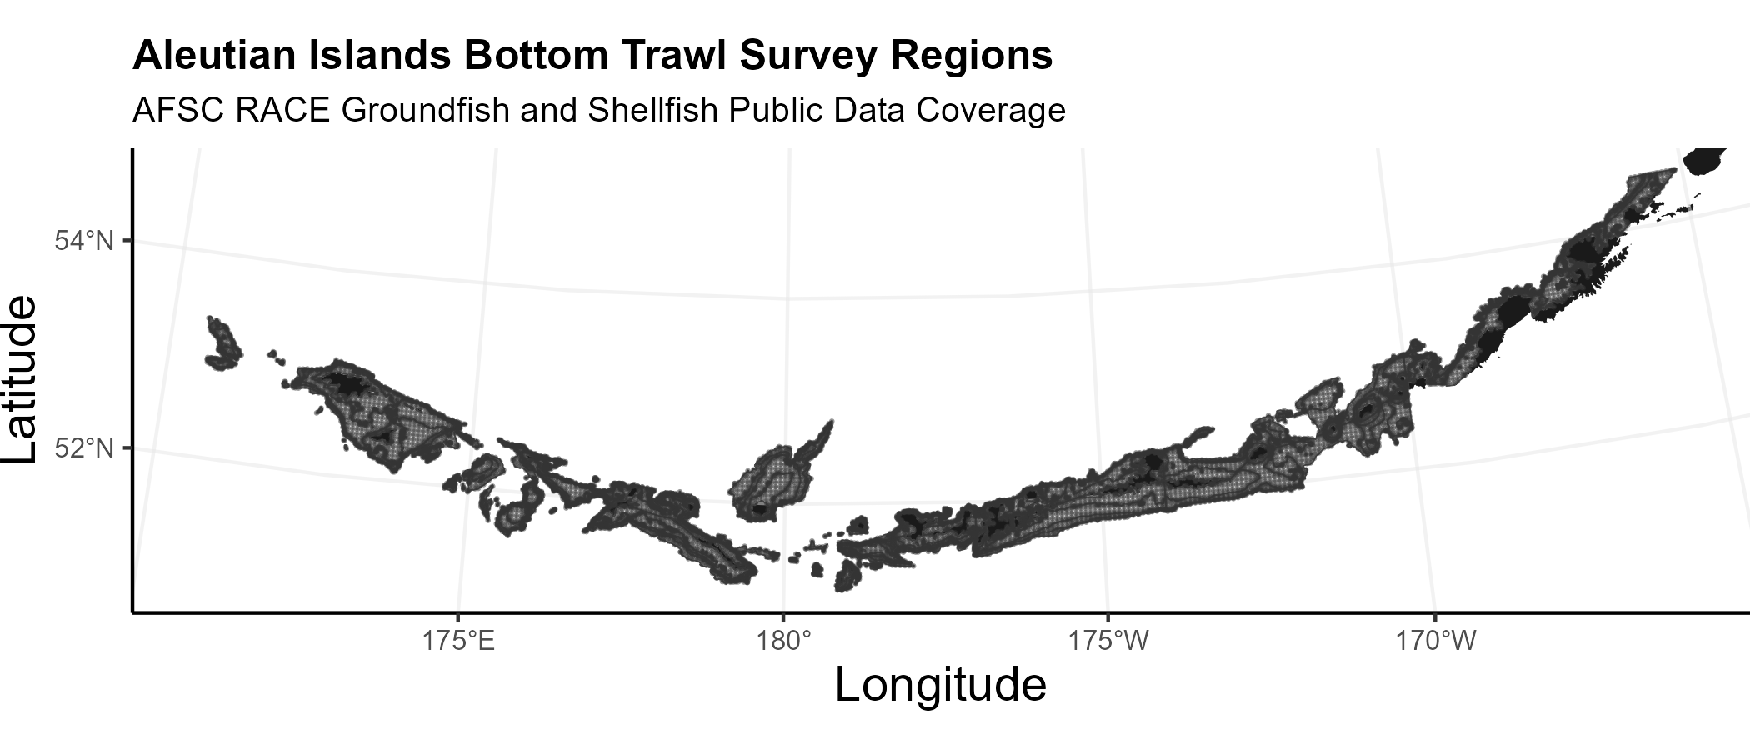
Strata used in the Aleutian Islands bottom trawl survey.

1.5.2 Gulf of Alaska
Most recent data report: (Von Szalay and Raring, 2018)
- Continental Shelf and Upper Slope of the Gulf of Alaska extending from the Islands of Four Mountains 2,300 km east to Dixon Entrance
- Triennial (1990s)/Biennial since 2001 in odd years, since 1991
- Stratified Random Survey Design
- Important commercial species in the Gulf of Alaska include Pacific ocean perch, walleye pollock, Pacific cod, flatfish, and other rockfish species.
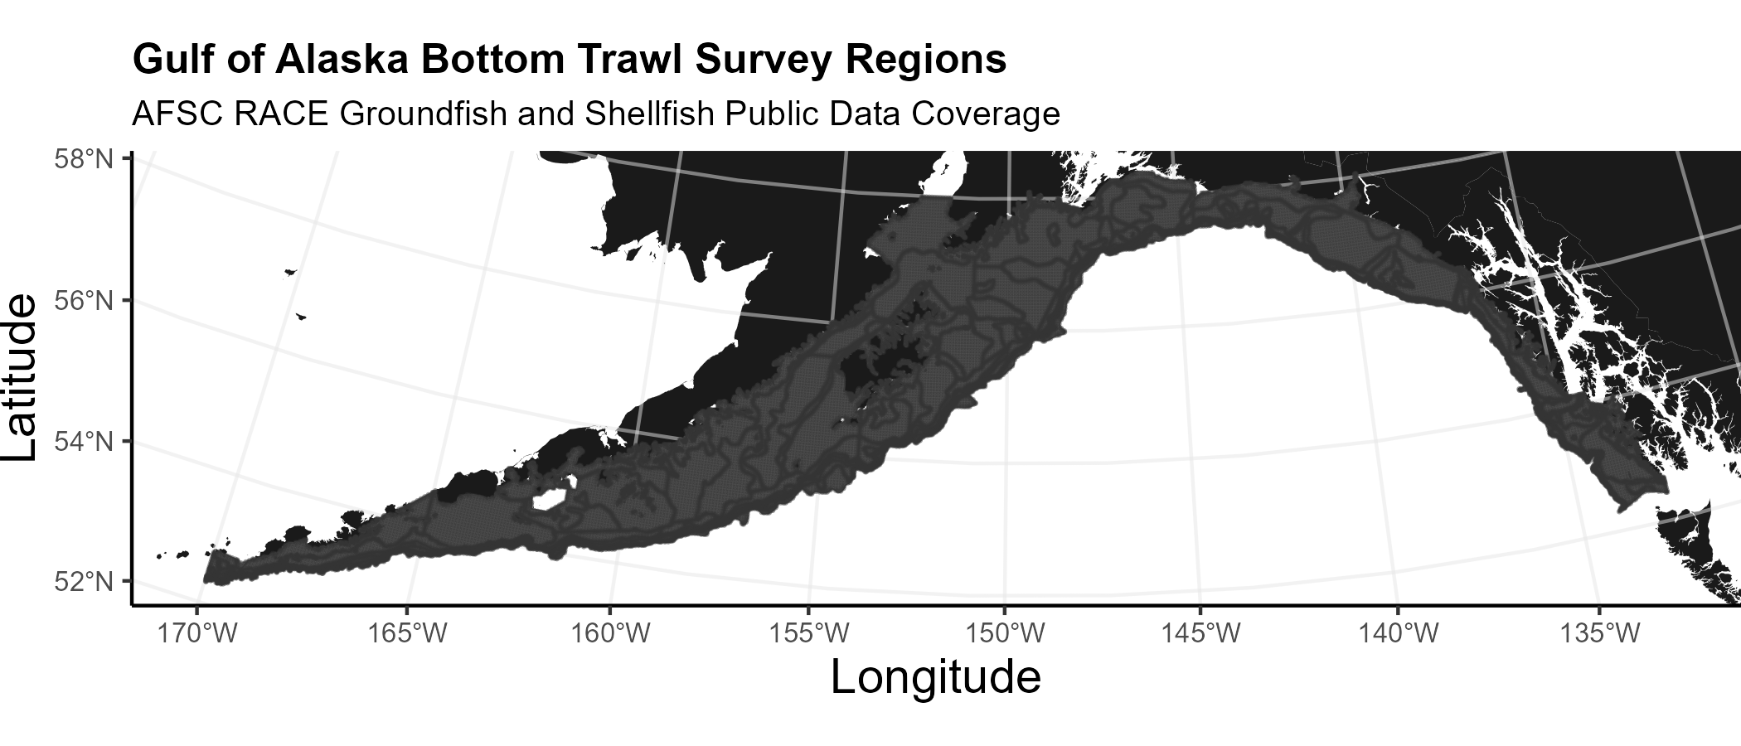
Strata used in the Gulf of Alaska bottom trawl survey.

1.5.3 Eastern Bering Sea Shelf
Most recent data report: (Markowitz et al., 2023)
- The continental shelf of the eastern Bering Sea from the Aleutian Islands to the Bering Strait
- Conducted annually since 1982.
- Uses a stratified systematic sampling survey design with fixed stations at center of 20 x 20 nm grid.
- Similar in design to the northern Bering Sea shelf bottom trawl survey.
- Focus species for the Bering Sea include walleye pollock, Pacific cod, Greenland turbot, yellowfin sole, northern rock sole, red king crab, and snow and Tanner crabs.
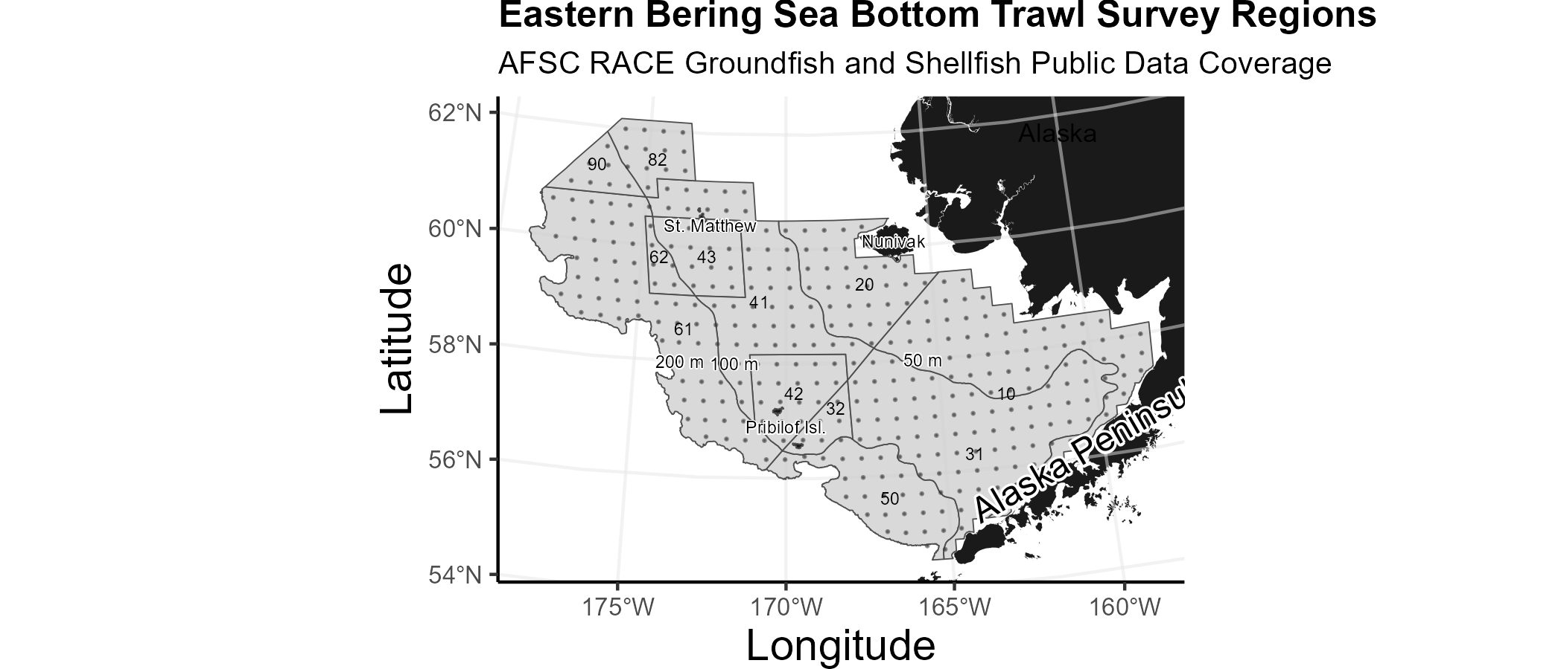
Strata used in the Eastern Bering Sea bottom trawl survey.

1.5.4 Northern Bering Sea
Most recent data report: (Markowitz et al., 2023)
- The continental shelf of the northern Bering Sea, including the area north of St. Lawrence Island and Norton Sound
- Biennial/Annual; conducted intermittently since 2010
- Uses a stratified systematic sampling survey design with fixed stations at center of 20 x 20 nm grid.
- Similar in design to the eastern Bering Sea shelf bottom trawl survey.
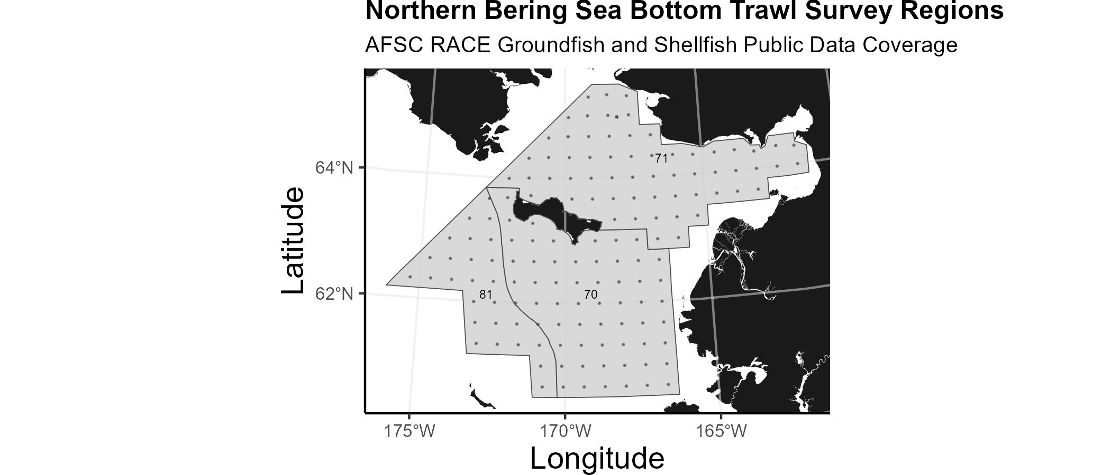
Strata used in the Northern Bering Sea bottom trawl survey.

1.5.5 Eastern Bering Sea Upper Continental Slope
Most recent data report: (Hoff, 2016)
- The eastern Bering Sea upper continental slope survey area extends from Unalaska and Akutan Islands to the U.S.-Russian Maritime Boundary at 61° N near the International Date Line (166° E to 180° W) at depths from 200 to 1,200 m
- Conducted intermittently since 2002 (funding dependent)
- Modified Index-Stratified Random of Successful Stations Survey Design
- Focus species for the Bering Sea slope include giant grenadier, Pacific ocean perch, popeye grenadier, walleye pollock, and arrowtooth flounder.
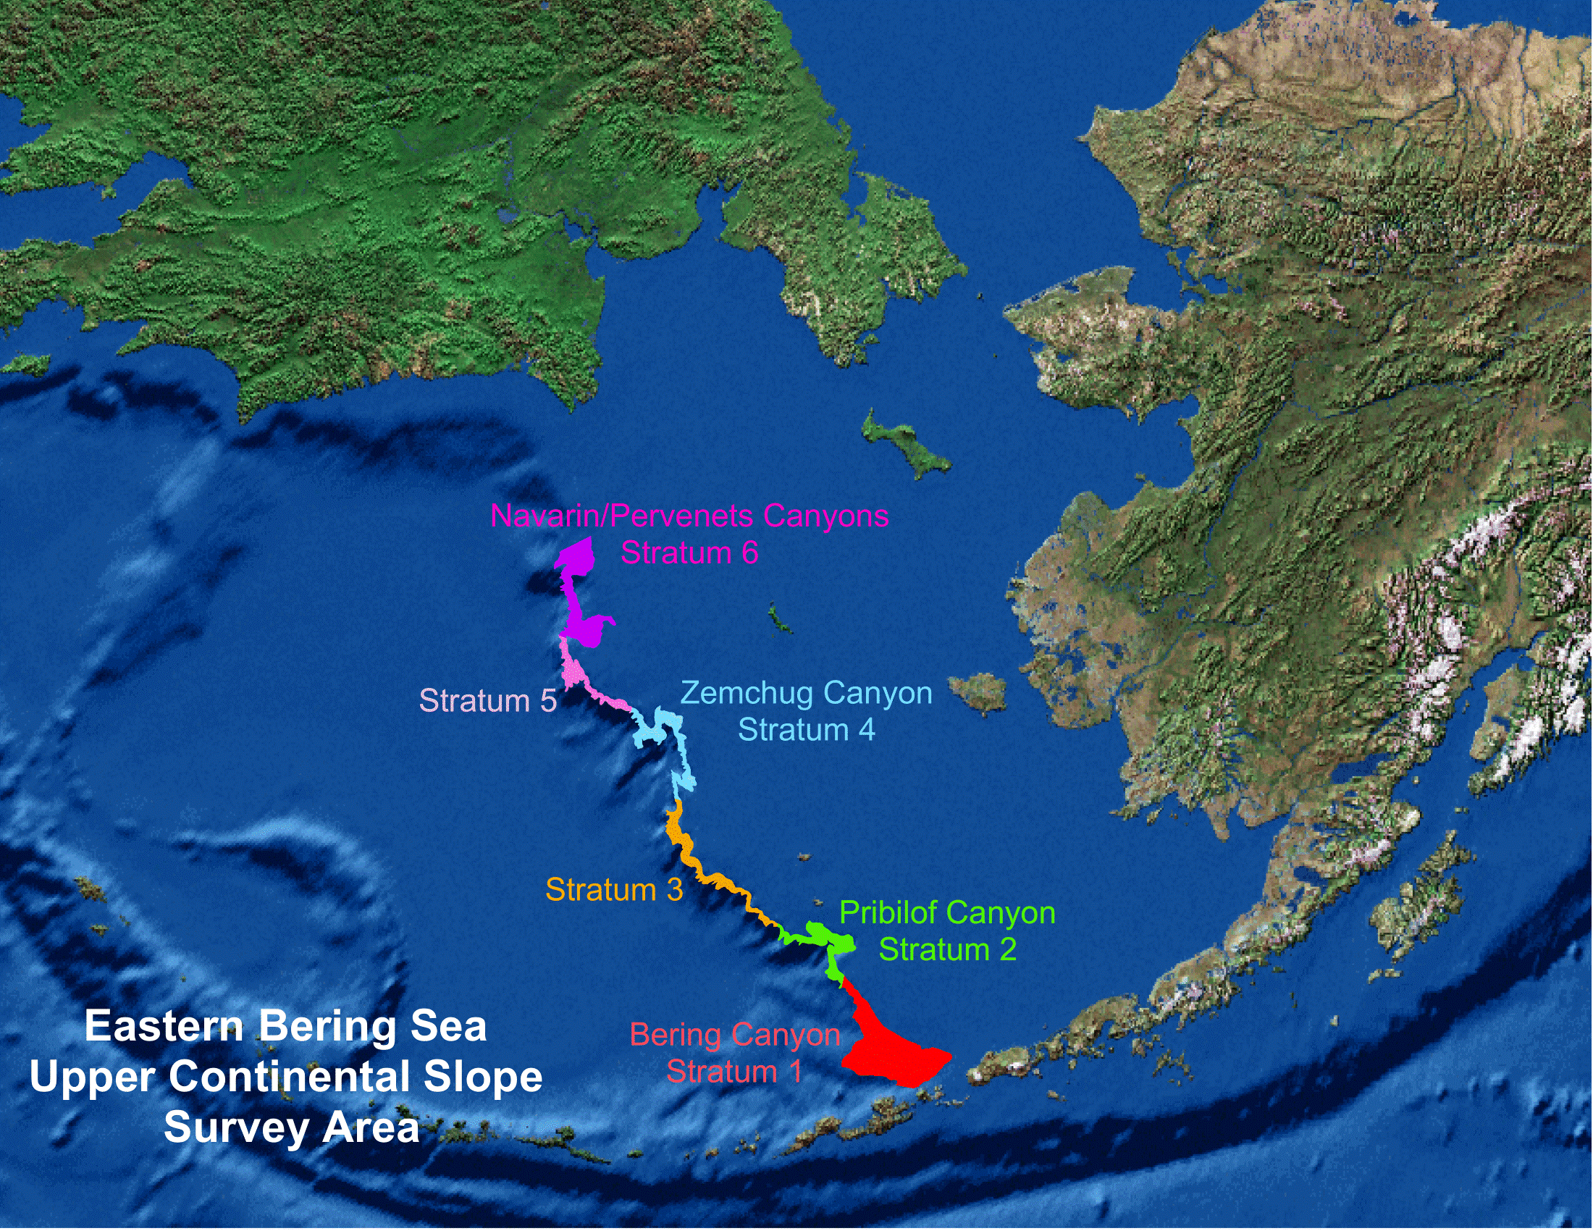
Strata used in the Bering Sea Slope bottom trawl survey.

2. Workflow

2.1 Operational Product Development Timeline
Over the course of the year, the survey team is developing a variety of different data products. Planning and preparation for surveys happens in the late winter and spring, surveys occur in the summer, data validation takes place over the course of the survey and after the survey, and data products are produced through fall and late winter.
 | January | February | March | April | May | June | July | August | September | October | November | December
Surveys |  |  |  |  | 1 | 1 | 1 | 1
Planning | 1 | 1 | 1 |  |  |  |  |  | 1 | 1 | 1 | 1
Development | 1 | 1 | 1 | 1 | 1 |  |  |  |  | 1 | 1 | 1
Deployment (survey deliverables) |  |  |  |  |  |  |  |  | 1 | 1 | 1 | 1
Deployment (survey operations) |  |  |  |  | 1 | 1 | 1 | 1
Triage (fixing bugs and errors) | 1 | 1 | 1 | 1 | 1 | 1 | 1 | 1 | 1 | 1 | 1 | 1
User feedback and brainstorming | 1 | 1 | 1 | 1 | 1 | 1 | 1 | 1 | 1 | 1 | 1 | 1

2.2 Data workflow from boat to production
Organisms first need to be collected aboard the vessel before data can be entered into tablets.
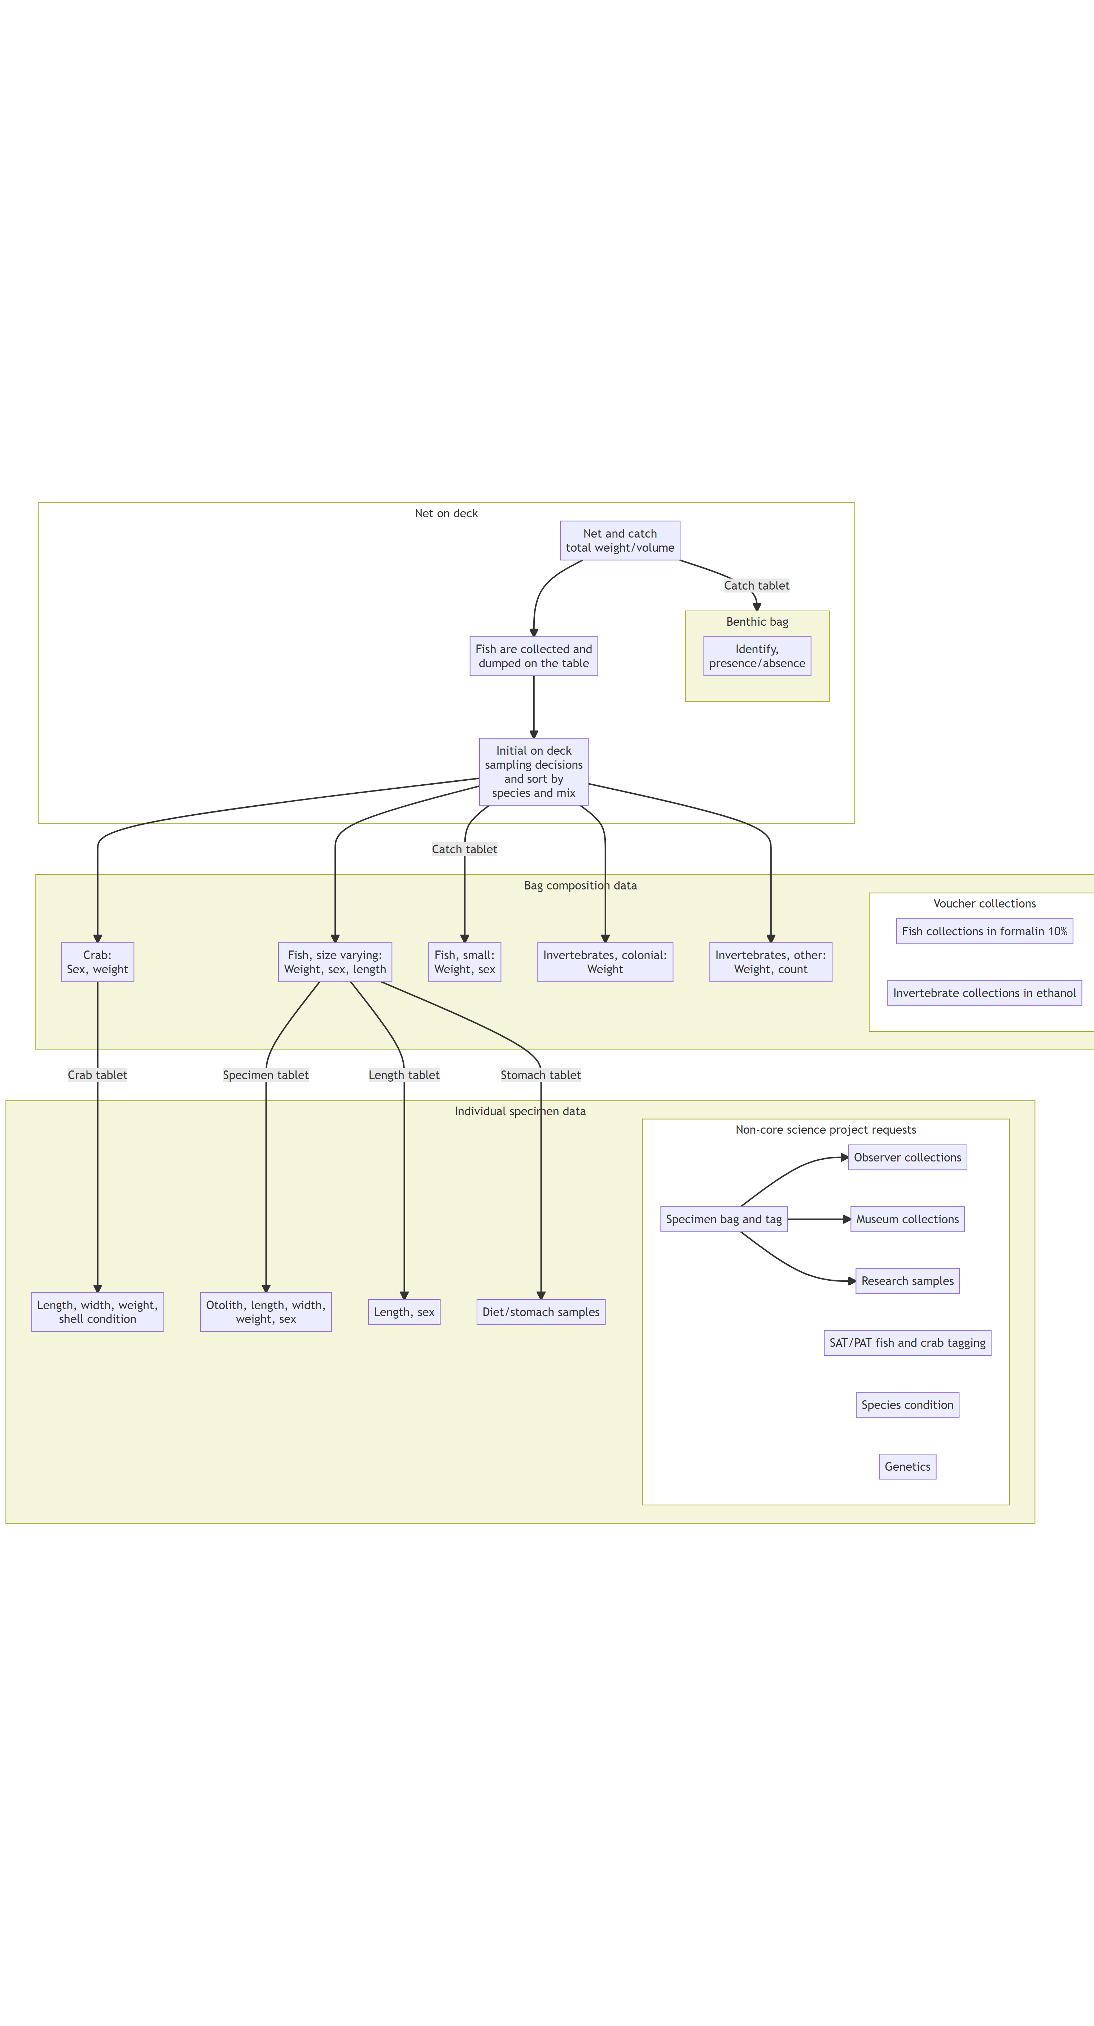
Figure 2.1: Simplified boat deck processing workflow.
The objective of this process is to take raw data, QA/QC and clean these data, curate standard data products for these survey. Please note, through this process we are not providing “data” (what we consider lower level data material; see the data levels section below) but “data products”, which is intended to facilitate the most fool-proof standard interpretation of the data. These data products only use data from standard and validated hauls, and has undergone careful review.
Once survey data collected on the vessel has been checked and validated, the gap_products/code/run.R script is used to orchestrate a sequence of programs that calculate the standard data products resulting from the NOAA AFSC GAP bottom trawl surveys. Standard data products are the CPUE, BIOMASS, SIZECOMP, and AGECOMP tables in the GAP_PRODUCTS Oracle schema. The tables are slated to be updated twice a year: once after the survey season following finalization of that summer’s bottom trawl survey data to incorporate the new catch, size, and effort data and once prior to an upcoming survey to incorporate new age data that were processed after the prior summer’s survey season ended. This second pre-survey production run will also incorporate changes in the data due to the specimen voucher process as well as other post-hoc changes in the survey data.
The data from these surveys constitute a living data set so we can continue to provide the best available data to all partners, stakeholders, and fellow scientists.
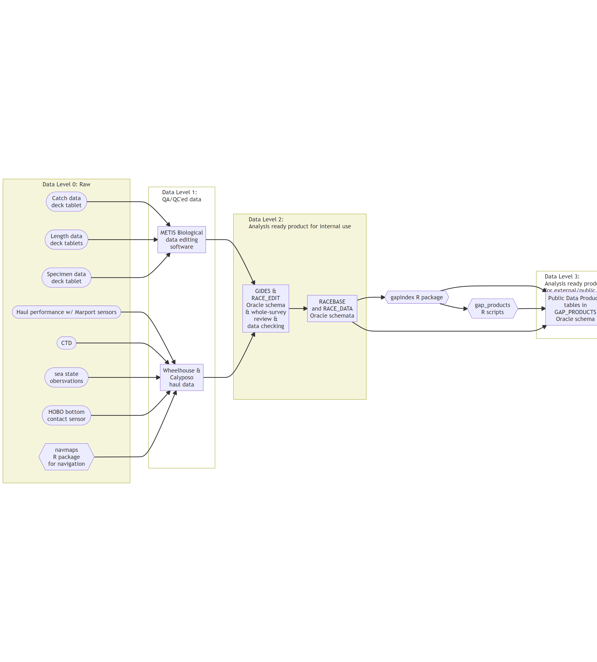
Figure 2.2: Simplified data workflow from boat to production.
During each data product run cycle:
- Versions of the tables in GAP_PRODUCTS are locally imported within the gap_products repository to compare with the updated production tables. Any changes to a production table will be compared and checked to make sure those changes are intentional and documented.
- Use the gapindex R package to calculate the four major standard data products: CPUE, BIOMASS, SIZECOMP, AGECOMP. These tables are compared and checked to their respective locally saved copies and any changes to the tables are vetted and documented. These tables are then uploaded to the GAP_PRODUCTS Oracle schema.
- Calculate the various materialized views for AKFIN and FOSS purposes. Since these are derivative of the tables in GAP_PRODUCTS as well as other base tables in RACEBASE and RACE_DATA, it is not necessary to check these views in addition to the data checks done in the previous steps.
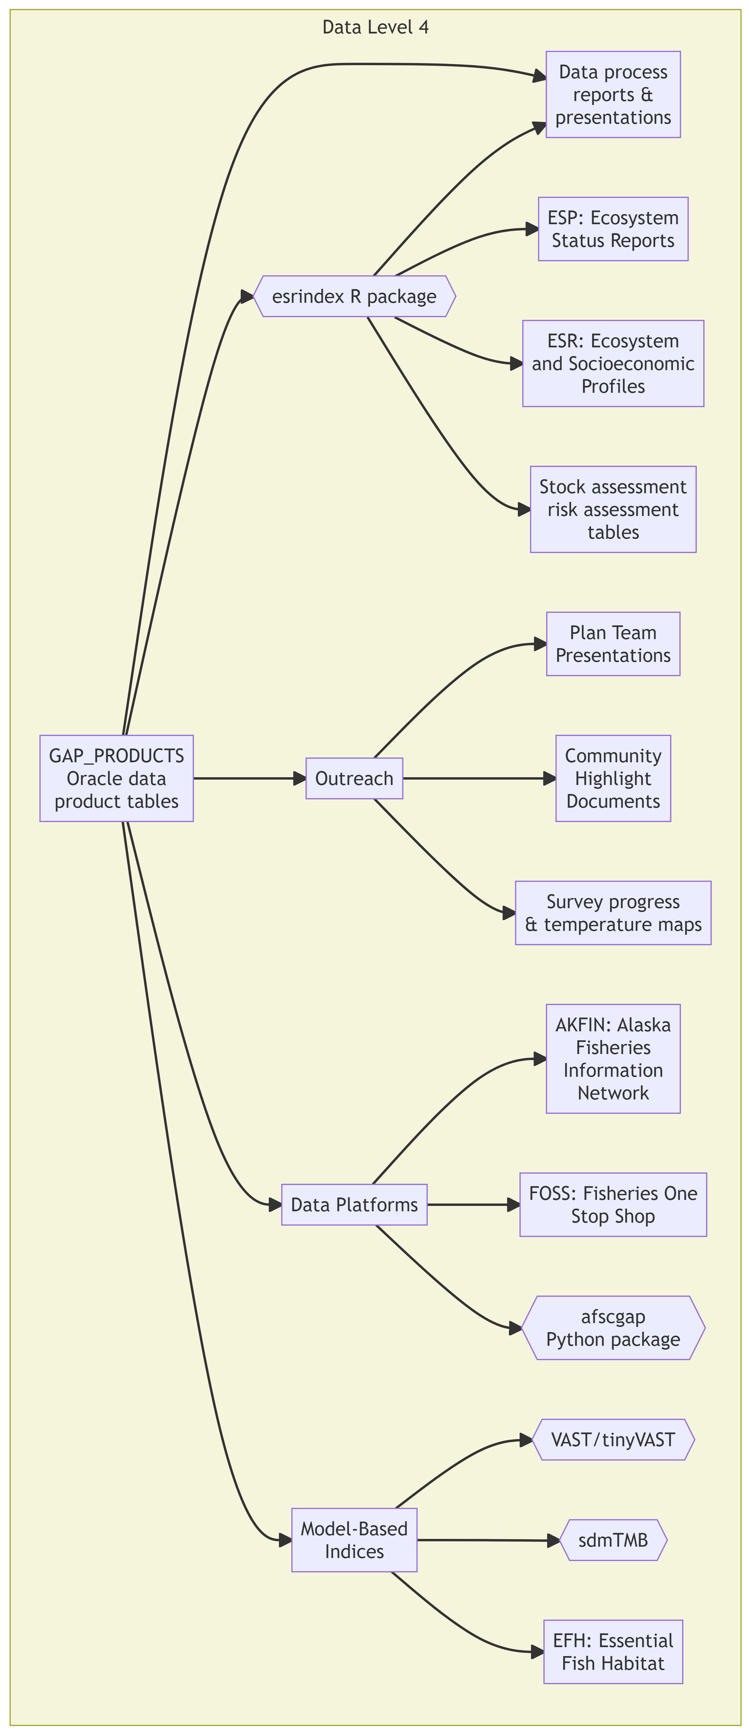
Figure 2.3: Major end-users of the GAP data product tables.

2.3 Data levels
GAP produces numerous data products that are subjected to different levels of processing, ranging from raw to highly-derived. The suitability of these data products for analysis varies and there is ambiguity about which data products can be used for which purpose. This ambiguity can create challenges in communicating about data products and potentially lead to misunderstanding and misuse of data. One approach to communicating about the level of processing applied to data products and their suitability for analysis is to describe data products using a Data Processing Level system. Data Processing Level systems are widely used in earth system sciences to characterize the extent of processing that has been applied to data products. For example, the NOAA National Centers for Environmental Information (NCEI) Satellite Program uses a Data Processing Level system to describe data on a scale of 0-4, where Level 0 is raw data and Level 4 is model output or results from analysis. Example of how NASA remote sensing data products are shared through a public data portal with levels of data processing and documentation.
For more information, see Sean Rohan’s October 2022 SCRUGS presentation on the topic.
- Level 0: Raw and unprocessed data. Ex: Data on the G drive, some tables in RACE_DATA
- Level 1: Data products with QA/QC applied that may or may not be expanded to analysis units, but either not georeferenced or does not include full metadata. Ex: Some tables in RACE_DATA and RACEBASE
- Level 2: Analysis-ready data products that are derived for a standardized extent and account for zeros and missing/bad data. Ex: CPUE tables, some data products in public-facing archives and repositories
- Level 3: Data products that are synthesized across a standardized extent, often inputs in a higher-level analytical product. Ex: Abundance indices, some data products in public-facing archives and repositories
- Level 4: Analytically generated data products that are derived from lower-level data, often to inform management. Ex: Biological reference points from stock assessments, Essential Fish Habitat layers, indicators in Ecosystem Status Reports and Ecosystem and Socioeconomic Profiles

3. News

3.1 News/change logs
– GAP_PRODUCTS ChangeLog (last produced on 2024-02-29) using gapindex v2.2.0: A new version of gapindex 2.2.0 was used for this production run and now accesses taxonomic information from RACEBASE.SPECIES instead of GAP_PRODUCTS.TAXONOMIC_CLASSIFICATION. As a result, there will be some SPECIES_CODE values that are supported due to slight differences between the two tables. Discussion in this github issue #54. As a result there are new cpue records for SPECIES_CODE values 22290 and 22292 and removed cpue records for SPECIES_CODE values 21345, 22200 and 69326.
– GAP_PRODUCTS ChangeLog (last produced on 2024-01-09) using gapindex v2.1.3: A new version of gapindex (v2.1.3) was used to produced these data. Data for SPECIES_CODE 68590 (Chionoecetes hybrids) are now removed, per this issue (https://github.com/afsc-gap-products/gap_products/issues/3). New read otolith data were incorporated into the age compositions. GOA depth subareas are now included in the size comps, and there were some modifications with EBS skate length data that are now incorporated into the length compositions.
– GAP_PRODUCTS ChangeLog (last produced on 2023-11-17) using gapindex v2.1.2: A new version of gapindex (v2.1.2) was used to produced these data. There was a slight change to how subarea biomass totals are calculated that was not fully addressed in v2.1.1. The modified biomass records reflect this change.
– GAP_PRODUCTS ChangeLog (last produced on 2023-11-14) using gapindex v2.1.1: A new version of gapindex (v2.1.1) was used to produced these data. There was a slight change to how subarea biomass totals are calculated. The modified biomass records reflect this change. New 2022 otolith data were available since the last iteration of the GAP_PRODUCTS for Aleutian Island Pacific ocean perch and northern rockifsh and Eastern Bering Sea northern rock sole. Zero-filled CPUE records for four GOA species codes (SPECIES_CODE: 21210, 30010, 30360, 77102, 98101) were added due to how the 1990 data were integrated in the last production run of GAP_PRODUCTS. Two Arctic cod (SPECIES_CODE: 21725) and one plain sculpin (SPECIES_CODE: 21371) count records were modified in the NBS data, which changes the numerical CPUE estimates for those hauls which changes the estimated population abundance and size composition for those species.
– Groundfish Assessment Program Survey Data Serving and Data Improvements: Initial data changes brief distributed to SSMA and other partners by Ned Laman, Zack Oyafuso, and Emily Markowitz
– Run 2023-06-01 gapindex v2.1.0: Initial compiling and planning notes

4. Code of Conduct

4.1 What are Codes of Conduct?
Codes of Conduct are voluntary sets of rules that assist creators, developers, and users of code and data with data protection compliance and accountability in specific sectors or relating to particular processing operations.
Codes can help organizations to ensure all participants follow best practices and rules designed specifically for their sector or processing operations, thus enhancing compliance and collaboration. They are developed and managed by an association or other body (the ‘Code Owner’) which is representative of a sector (or category of data controllers or processors), with the expert and sectoral knowledge of how to enhance data protection in their area.

4.1.1 Code of Conduct from the nmfs-opensci GitHub.

5. NOAA Fisheries Open Science Code of Conduct
This code of conduct was developed and adapted from the Atom code of conduct in October 2021.

5.1 Our Pledge
In the interest of fostering an open and welcoming environment, we as contributors and maintainers pledge to making participation in our project and our community a harassment-free experience for everyone, regardless of age, body size, disability, ethnicity, gender identity and expression, level of experience, nationality, personal appearance, race, religion, or sexual identity and orientation.

5.2 Our Standards
Examples of behavior that contributes to creating a positive environment include:
- Using welcoming and inclusive language
- Being respectful of differing viewpoints and experiences
- Gracefully accepting constructive criticism
- Focusing on what is best for the community
- Showing empathy towards other community members
Examples of unacceptable behavior by participants include:
- The use of sexualized language or imagery and unwelcome sexual attention or advances
- Trolling, insulting/derogatory comments, and personal or political attacks
- Public or private harassment
- Publishing others’ private information, such as a physical or electronic address, without explicit permission
- Other conduct which could reasonably be considered inappropriate in a professional setting

5.3 Our Responsibilities
Project maintainers are responsible for clarifying the standards of acceptable behavior and are expected to take appropriate and fair corrective action in response to any instances of unacceptable behavior.
Project maintainers have the right and responsibility to remove, edit, or reject comments, commits, code, wiki edits, issues, and other contributions that are not aligned to this Code of Conduct, or to ban temporarily or permanently any contributor for other behaviors that they deem inappropriate, threatening, offensive, or harmful.

5.4 Scope
This Code of Conduct applies both within project spaces and in public spaces when an individual is representing the project or its community. Examples of representing a project or community include using an official project e-mail address, posting via an official social media account, or acting as an appointed representative at an online or offline event. Representation of a project may be further defined and clarified by project maintainers.

5.5 Enforcement
Instances of abusive, harassing, or otherwise unacceptable behavior may be reported by contacting the project team. All complaints will be reviewed and investigated and will result in a response that is deemed necessary and appropriate to the circumstances. Further details of specific enforcement policies may be posted separately.

5.6 Attribution
This Code of Conduct is adapted from the Contributor Covenant, version 1.4, available at https://contributor-covenant.org/version/1/4

6. Data description

6.1 Data tables

6.1.1 AGECOMP
Region-level age compositions by sex/length bin.
Number of rows: 662,289
Number of columns: 10
Column name from data
Descriptive column Name
Units
Oracle data type
Column description
AGE
Taxon age bin (yrs)
integer
NUMBER(38,0)
Age bin of taxon. Age bin of a taxon in years estimated by the age comp estimate.
AREA_ID
Area ID
ID key code
NUMBER(38,0)
Area ID key code for each statistical area used to produce production estimates (e.g., biomass, population, age comps, length comps). Each area ID is unique within each survey.
AREA_ID_FOOTPRINT
NA
NA
NA
NA
LENGTH_MM_MEAN
Mean length at age weighted by numbers at length
numeric
NUMBER(38,3)
Mean length (millimeters)
LENGTH_MM_SD
Standard deviation of length at age weighted by numbers at length
numeric
NUMBER(38,3)
Variance of mean length.
POPULATION_COUNT
Estimated population
numeric
NUMBER(38,0)
The estimated population caught in the survey for a species, group, or total for a given survey.
SEX
Sex of a specimen
ID key code
NUMBER(38,0)
Sex of a specimen where “1” = “Male”, “2” = “Female”, “3” = Unsexed.
SPECIES_CODE
Taxon code
ID key code
NUMBER(38,0)
The species code of the organism associated with the ‘common_name’ and ‘scientific_name’ columns. For a complete species list, review the code books.
SURVEY_DEFINITION_ID
Survey ID
ID key code
NUMBER(38,0)
The survey definition ID key code uniquely identifies a survey/survey design. Integer code that uniquely identifies survey. Full list of survey definition IDs are in RACE_DATA.SURVEY_DEFINITIONS. IDs used in GAP_PRODUCTS are: 47 (Gulf of Alaska); 52 (Aleutian Islands); 78 (Bering Sea Slope); 98 (Eastern Bering Sea Shelf); 143 (Northern Bering Sea Shelf). The column ‘survey_definition_id’ is associated with the ‘srvy’ and ‘survey’ columns. For a complete list of surveys, review the code books.
YEAR
Survey year
year
NUMBER(10,0)
Year the observation (survey) was collected.

6.1.2 AREA
This table contains all of the information related to the various strata, subareas, INPFC and NMFS management areas, and regions for the Aleutian Islands, Gulf of Alaska, and Bering Sea shelf and slope bottom trawl surveys. These tables are created by the Resource Assessment and Conservation Engineering Division (RACE) Groundfish Assessment Program (GAP) of the Alaska Fisheries Science Center (AFSC). The GitHub repository for the scripts that created this code can be found at https://github.com/afsc-gap-products/gap_products. These data were last updated April 02, 2024. There are no legal restrictions on access to the data. For more information about codes used in the tables, please refer to the survey code books (https://www.fisheries.noaa.gov/resource/document/groundfish-survey-species-code-manual-and-data-codes-manual).
Number of rows: 395
Number of columns: 9
Column name from data
Descriptive column Name
Units
Oracle data type
Column description
AREA_ID
Area ID
ID key code
NUMBER(38,0)
Area ID key code for each statistical area used to produce production estimates (e.g., biomass, population, age comps, length comps). Each area ID is unique within each survey.
AREA_KM2
Area (km2)
kilometers squared
NUMBER(38,3)
Area in square kilometers.
AREA_NAME
Area ID name
text
VARCHAR2(4000 BYTE)
Descriptive name of each AREA_ID. These names often identify the region, depth ranges, or other regional information for the area ID.
AREA_TYPE
Area ID type description
category
VARCHAR2(255 BYTE)
The type of stratum that AREA_ID represents. Types include: STRATUM (the smallest building-block unit of area in these surveys), REGION, DEPTH, SUBAREA, INPFC BY DEPTH, INPFC, SUBAREA BY DEPTH, REGULATORY AREA, NMFS STATISTICAL AREA.
DEPTH_MAX_M
Area ID maximum depth (m)
meters
NUMBER(38,3)
Maximum depth (meters).
DEPTH_MIN_M
Area ID minimum depth (m)
meters
NUMBER(38,3)
Minimum depth (meters).
DESCRIPTION
Description
text
VARCHAR2(4000 BYTE)
Description of row observation.
DESIGN_YEAR
Design year
year
NUMBER(10,0)
Year ID associated with a given value AREA_ID. This field describes the changes in the survey design over time.
SURVEY_DEFINITION_ID
Survey ID
ID key code
NUMBER(38,0)
The survey definition ID key code uniquely identifies a survey/survey design. Integer code that uniquely identifies survey. Full list of survey definition IDs are in RACE_DATA.SURVEY_DEFINITIONS. IDs used in GAP_PRODUCTS are: 47 (Gulf of Alaska); 52 (Aleutian Islands); 78 (Bering Sea Slope); 98 (Eastern Bering Sea Shelf); 143 (Northern Bering Sea Shelf). The column ‘survey_definition_id’ is associated with the ‘srvy’ and ‘survey’ columns. For a complete list of surveys, review the code books.

6.1.3 BIOMASS
Stratum/subarea/region-level mean CPUE (weight and numbers), total biomass, and total abundance with associated variances.
Number of rows: 2,576,866
Number of columns: 16
Column name from data
Descriptive column Name
Units
Oracle data type
Column description
AREA_ID
Area ID
ID key code
NUMBER(38,0)
Area ID key code for each statistical area used to produce production estimates (e.g., biomass, population, age comps, length comps). Each area ID is unique within each survey.
BIOMASS_MT
Estimated biomass
numeric
NUMBER(38,6)
The estimated total biomass.
BIOMASS_VAR
Estimated biomass variance
numeric
NUMBER(38,6)
The estimated variance associated with the total biomass.
CPUE_KGKM2_MEAN
Mean weight CPUE
kilograms per kilometers squared
NUMBER(38,6)
The mean catch weight (kilograms) per unit effort (area swept by the net, units squared kilometers).
CPUE_KGKM2_VAR
Variance of the mean weight CPUE
kilograms per kilometers squared
NUMBER(38,6)
The variance of mean catch weight (kilograms) per unit effort (area swept by the net, units squared kilometers).
CPUE_NOKM2_MEAN
Mean numeric CPUE
count per kilometers squared
NUMBER(38,6)
The mean of numerical catch per unit effort (area swept by the net, units square kilometers).
CPUE_NOKM2_VAR
Variance of the mean numeric CPUE
count per kilometers squared
NUMBER(38,6)
The variance of mean numerical catch per unit effort (area swept by the net, units square kilometers).
N_COUNT
Hauls with taxon counts
numeric
NUMBER(38,0)
Total number of hauls with positive count data.
N_HAUL
Valid hauls
count
NUMBER(38,0)
Total number of hauls.
N_LENGTH
Hauls with taxon lengths
count
NUMBER(38,0)
Total number of hauls with length data.
N_WEIGHT
Hauls with catch
count
NUMBER(38,0)
Total number of hauls with positive catch biomass.
POPULATION_COUNT
Estimated population
numeric
NUMBER(38,0)
The estimated population caught in the survey for a species, group, or total for a given survey.
POPULATION_VAR
Estimated population variance
numeric
NUMBER(38,6)
The estimated population variance caught in the survey for a species, group, or total for a given survey.
SPECIES_CODE
Taxon code
ID key code
NUMBER(38,0)
The species code of the organism associated with the ‘common_name’ and ‘scientific_name’ columns. For a complete species list, review the code books.
SURVEY_DEFINITION_ID
Survey ID
ID key code
NUMBER(38,0)
The survey definition ID key code uniquely identifies a survey/survey design. Integer code that uniquely identifies survey. Full list of survey definition IDs are in RACE_DATA.SURVEY_DEFINITIONS. IDs used in GAP_PRODUCTS are: 47 (Gulf of Alaska); 52 (Aleutian Islands); 78 (Bering Sea Slope); 98 (Eastern Bering Sea Shelf); 143 (Northern Bering Sea Shelf). The column ‘survey_definition_id’ is associated with the ‘srvy’ and ‘survey’ columns. For a complete list of surveys, review the code books.
YEAR
Survey year
year
NUMBER(10,0)
Year the observation (survey) was collected.

6.1.4 CPUE
Haul-level zero-filled weight and numerical catch-per-unit-effort.
Number of rows: 21,360,338
Number of columns: 7
Column name from data
Descriptive column Name
Units
Oracle data type
Column description
AREA_SWEPT_KM2
Area swept (km)
kilometers
NUMBER(38,6)
The area the net covered while the net was fishing (kilometers squared), defined as the distance fished times the net width.
COUNT
Taxon count
count, whole number resolution
NUMBER(38,0)
Total whole number of individuals caught in haul or samples collected.
CPUE_KGKM2
Weight CPUE (kg/km2)
kilograms per kilometers squared
NUMBER(38,6)
Catch weight (kilograms) per unit effort (area swept by the net, units square kilometers).
CPUE_NOKM2
Number CPUE (no/km2)
count per kilometers squared
NUMBER(38,6)
Numerical catch per unit effort (area swept by the net, units square kilometers).
HAULJOIN
Haul ID
ID key code
NUMBER(38,0)
This is a unique numeric identifier assigned to each (vessel, cruise, and haul) combination.
SPECIES_CODE
Taxon code
ID key code
NUMBER(38,0)
The species code of the organism associated with the ‘common_name’ and ‘scientific_name’ columns. For a complete species list, review the code books.
WEIGHT_KG
Sample or taxon weight (kg)
kilograms
NUMBER(38,3)
Weight (thousandths of a kilogram) of individuals in a haul by taxon.

6.1.5 SURVEY_DESIGN
This table contains for a given survey (via SURVEY_DEFINITION_ID) and survey year (YEAR), which version (DESIGN_YEAR) of the AREA_IDs that were used to calculate the various standard data products. These tables are created by the Resource Assessment and Conservation Engineering Division (RACE) Groundfish Assessment Program (GAP) of the Alaska Fisheries Science Center (AFSC). The GitHub repository for the scripts that created this code can be found at https://github.com/afsc-gap-products/gap_products. These data were last updated April 02, 2024. There are no legal restrictions on access to the data. For more information about codes used in the tables, please refer to the survey code books (https://www.fisheries.noaa.gov/resource/document/groundfish-survey-species-code-manual-and-data-codes-manual).
Number of rows: 87
Number of columns: 3
Column name from data
Descriptive column Name
Units
Oracle data type
Column description
DESIGN_YEAR
Design year
year
NUMBER(10,0)
Year ID associated with a given value AREA_ID. This field describes the changes in the survey design over time.
SURVEY_DEFINITION_ID
Survey ID
ID key code
NUMBER(38,0)
The survey definition ID key code uniquely identifies a survey/survey design. Integer code that uniquely identifies survey. Full list of survey definition IDs are in RACE_DATA.SURVEY_DEFINITIONS. IDs used in GAP_PRODUCTS are: 47 (Gulf of Alaska); 52 (Aleutian Islands); 78 (Bering Sea Slope); 98 (Eastern Bering Sea Shelf); 143 (Northern Bering Sea Shelf). The column ‘survey_definition_id’ is associated with the ‘srvy’ and ‘survey’ columns. For a complete list of surveys, review the code books.
YEAR
Survey year
year
NUMBER(10,0)
Year the observation (survey) was collected.

6.1.6 METADATA_TABLE
These columns provide the table metadata for all of the tables and views in GAP_PRODUCTS. These tables are created by the Resource Assessment and Conservation Engineering Division (RACE) Groundfish Assessment Program (GAP) of the Alaska Fisheries Science Center (AFSC). The GitHub repository for the scripts that created this code can be found at https://github.com/afsc-gap-products/gap_products. These data were last updated April 02, 2024. There are no legal restrictions on access to the data. For more information about codes used in the tables, please refer to the survey code books (https://www.fisheries.noaa.gov/resource/document/groundfish-survey-species-code-manual-and-data-codes-manual).
Number of rows: 8
Number of columns: 3
Column name from data
Descriptive column Name
Units
Oracle data type
Column description
METADATA_SENTENCE
Sentence
text
VARCHAR2(4000 BYTE)
Table metadata sentence.
METADATA_SENTENCE_NAME
Metadata sentence name
text
VARCHAR2(4000 BYTE)
Name of table metadata sentence.
METADATA_SENTENCE_TYPE
Sentence type
text
VARCHAR2(4000 BYTE)
Type of sentence to have in table metadata.

6.1.7 STRATUM_GROUPS
This table contains all of strata that are contained within a given subarea, INPFC or NMFS management area, or region for the Aleutian Islands, Gulf of Alaska, and Bering Sea shelf and slope bottom trawl surveys. These tables are created by the Resource Assessment and Conservation Engineering Division (RACE) Groundfish Assessment Program (GAP) of the Alaska Fisheries Science Center (AFSC). The GitHub repository for the scripts that created this code can be found at https://github.com/afsc-gap-products/gap_products. These data were last updated April 02, 2024. There are no legal restrictions on access to the data. For more information about codes used in the tables, please refer to the survey code books (https://www.fisheries.noaa.gov/resource/document/groundfish-survey-species-code-manual-and-data-codes-manual).
Number of rows: 768
Number of columns: 4
Column name from data
Descriptive column Name
Units
Oracle data type
Column description
AREA_ID
Area ID
ID key code
NUMBER(38,0)
Area ID key code for each statistical area used to produce production estimates (e.g., biomass, population, age comps, length comps). Each area ID is unique within each survey.
DESIGN_YEAR
Design year
year
NUMBER(10,0)
Year ID associated with a given value AREA_ID. This field describes the changes in the survey design over time.
STRATUM
Stratum ID
ID key code
NUMBER(10,0)
RACE database statistical area for analyzing data. Strata were designed using bathymetry and other geographic and habitat-related elements. The strata are unique to each survey region. Stratum of value 0 indicates experimental tows.
SURVEY_DEFINITION_ID
Survey ID
ID key code
NUMBER(38,0)
The survey definition ID key code uniquely identifies a survey/survey design. Integer code that uniquely identifies survey. Full list of survey definition IDs are in RACE_DATA.SURVEY_DEFINITIONS. IDs used in GAP_PRODUCTS are: 47 (Gulf of Alaska); 52 (Aleutian Islands); 78 (Bering Sea Slope); 98 (Eastern Bering Sea Shelf); 143 (Northern Bering Sea Shelf). The column ‘survey_definition_id’ is associated with the ‘srvy’ and ‘survey’ columns. For a complete list of surveys, review the code books.

6.1.8 SIZECOMP
Stratum/subarea/region-level size compositions by sex. This table was created by the Resource Assessment and Conservation Engineering Division (RACE) Groundfish Assessment Program (GAP) of the Alaska Fisheries Science Center (AFSC). There are legal restrictions on access to the data. These data are not intended for public dissemination and should not be shared without the explicit written consent of the data managers and owners (NOAA Fisheries). The GitHub repository for the scripts that created this code can be found at https://github.com/afsc-gap-products/gap_products. For more information about codes used in the tables, please refer to the survey code books (https://www.fisheries.noaa.gov/resource/document/groundfish-survey-species-code-manual-and-data-codes-manual). These data were last updated April 10, 2024.
Number of rows: 3,209,517
Number of columns: 7
Column name from data
Descriptive column Name
Units
Oracle data type
Column description
AREA_ID
Area ID
ID key code
NUMBER(38,0)
Area ID key code for each statistical area used to produce production estimates (e.g., biomass, population, age comps, length comps). Each area ID is unique within each survey.
LENGTH_MM
Length of a specimen
millimeters
NUMBER(10,0)
Length bin in millimeters.
POPULATION_COUNT
Estimated population
numeric
NUMBER(38,0)
The estimated population caught in the survey for a species, group, or total for a given survey.
SEX
Sex of a specimen
ID key code
NUMBER(38,0)
Sex of a specimen where “1” = “Male”, “2” = “Female”, “3” = Unsexed.
SPECIES_CODE
Taxon code
ID key code
NUMBER(38,0)
The species code of the organism associated with the ‘common_name’ and ‘scientific_name’ columns. For a complete species list, review the code books.
SURVEY_DEFINITION_ID
Survey ID
ID key code
NUMBER(38,0)
The survey definition ID key code uniquely identifies a survey/survey design. Integer code that uniquely identifies survey. Full list of survey definition IDs are in RACE_DATA.SURVEY_DEFINITIONS. IDs used in GAP_PRODUCTS are: 47 (Gulf of Alaska); 52 (Aleutian Islands); 78 (Bering Sea Slope); 98 (Eastern Bering Sea Shelf); 143 (Northern Bering Sea Shelf). The column ‘survey_definition_id’ is associated with the ‘srvy’ and ‘survey’ columns. For a complete list of surveys, review the code books.
YEAR
Survey year
year
NUMBER(10,0)
Year the observation (survey) was collected.

7. Data description
AKFIN Answers is an Oracle BI tool used for distributing data to stock assessors and other users. Usernames and passwords are distinct from direct AKFIN database credentials.

7.1 Data tables

7.1.1 AKFIN_AGECOMP
This table is a copy of GAP_PRODUCTS.AGECOMP and does not have any other object dependencies. These data are produced by the Resource Assessment and Conservation Engineering Division (RACE) Groundfish Assessment Program (GAP) of the Alaska Fisheries Science Center (AFSC). There are legal restrictions on access to the data. These data are not intended for public dissemination and should not be shared without the explicit written consent of the data managers and owners (NOAA Fisheries). The GitHub repository for the scripts that created this code can be found at https://github.com/afsc-gap-products/gap_products. These data were last updated April 10, 2024.
Number of rows: 662,289
Number of columns: 10
Column name from data
Descriptive column Name
Units
Oracle data type
Column description
AGE
Taxon age bin (yrs)
integer
NUMBER(38,0)
Age bin of taxon. Age bin of a taxon in years estimated by the age comp estimate.
AREA_ID
Area ID
ID key code
NUMBER(38,0)
Area ID key code for each statistical area used to produce production estimates (e.g., biomass, population, age comps, length comps). Each area ID is unique within each survey.
AREA_ID_FOOTPRINT
NA
NA
NA
NA
LENGTH_MM_MEAN
Mean length at age weighted by numbers at length
numeric
NUMBER(38,3)
Mean length (millimeters)
LENGTH_MM_SD
Standard deviation of length at age weighted by numbers at length
numeric
NUMBER(38,3)
Variance of mean length.
POPULATION_COUNT
Estimated population
numeric
NUMBER(38,0)
The estimated population caught in the survey for a species, group, or total for a given survey.
SEX
Sex of a specimen
ID key code
NUMBER(38,0)
Sex of a specimen where “1” = “Male”, “2” = “Female”, “3” = Unsexed.
SPECIES_CODE
Taxon code
ID key code
NUMBER(38,0)
The species code of the organism associated with the ‘common_name’ and ‘scientific_name’ columns. For a complete species list, review the code books.
SURVEY_DEFINITION_ID
Survey ID
ID key code
NUMBER(38,0)
The survey definition ID key code uniquely identifies a survey/survey design. Integer code that uniquely identifies survey. Full list of survey definition IDs are in RACE_DATA.SURVEY_DEFINITIONS. IDs used in GAP_PRODUCTS are: 47 (Gulf of Alaska); 52 (Aleutian Islands); 78 (Bering Sea Slope); 98 (Eastern Bering Sea Shelf); 143 (Northern Bering Sea Shelf). The column ‘survey_definition_id’ is associated with the ‘srvy’ and ‘survey’ columns. For a complete list of surveys, review the code books.
YEAR
Survey year
year
NUMBER(10,0)
Year the observation (survey) was collected.

7.1.2 AKFIN_AREA
This table is a copy of GAP_PRODUCTS.AREA and does not have any other object dependencies. These data are produced by the Resource Assessment and Conservation Engineering Division (RACE) Groundfish Assessment Program (GAP) of the Alaska Fisheries Science Center (AFSC). There are legal restrictions on access to the data. These data are not intended for public dissemination and should not be shared without the explicit written consent of the data managers and owners (NOAA Fisheries). The GitHub repository for the scripts that created this code can be found at https://github.com/afsc-gap-products/gap_products. These data were last updated April 10, 2024.
Number of rows: 395
Number of columns: 9
Column name from data
Descriptive column Name
Units
Oracle data type
Column description
AREA_ID
Area ID
ID key code
NUMBER(38,0)
Area ID key code for each statistical area used to produce production estimates (e.g., biomass, population, age comps, length comps). Each area ID is unique within each survey.
AREA_KM2
Area (km2)
kilometers squared
NUMBER(38,3)
Area in square kilometers.
AREA_NAME
Area ID name
text
VARCHAR2(4000 BYTE)
Descriptive name of each AREA_ID. These names often identify the region, depth ranges, or other regional information for the area ID.
AREA_TYPE
Area ID type description
category
VARCHAR2(255 BYTE)
The type of stratum that AREA_ID represents. Types include: STRATUM (the smallest building-block unit of area in these surveys), REGION, DEPTH, SUBAREA, INPFC BY DEPTH, INPFC, SUBAREA BY DEPTH, REGULATORY AREA, NMFS STATISTICAL AREA.
DEPTH_MAX_M
Area ID maximum depth (m)
meters
NUMBER(38,3)
Maximum depth (meters).
DEPTH_MIN_M
Area ID minimum depth (m)
meters
NUMBER(38,3)
Minimum depth (meters).
DESCRIPTION
Description
text
VARCHAR2(4000 BYTE)
Description of row observation.
DESIGN_YEAR
Design year
year
NUMBER(10,0)
Year ID associated with a given value AREA_ID. This field describes the changes in the survey design over time.
SURVEY_DEFINITION_ID
Survey ID
ID key code
NUMBER(38,0)
The survey definition ID key code uniquely identifies a survey/survey design. Integer code that uniquely identifies survey. Full list of survey definition IDs are in RACE_DATA.SURVEY_DEFINITIONS. IDs used in GAP_PRODUCTS are: 47 (Gulf of Alaska); 52 (Aleutian Islands); 78 (Bering Sea Slope); 98 (Eastern Bering Sea Shelf); 143 (Northern Bering Sea Shelf). The column ‘survey_definition_id’ is associated with the ‘srvy’ and ‘survey’ columns. For a complete list of surveys, review the code books.

7.1.3 AKFIN_BIOMASS
This table is a copy of GAP_PRODUCTS.BIOMASS and does not have any other object dependencies. These data are produced by the Resource Assessment and Conservation Engineering Division (RACE) Groundfish Assessment Program (GAP) of the Alaska Fisheries Science Center (AFSC). There are legal restrictions on access to the data. These data are not intended for public dissemination and should not be shared without the explicit written consent of the data managers and owners (NOAA Fisheries). The GitHub repository for the scripts that created this code can be found at https://github.com/afsc-gap-products/gap_products. These data were last updated April 10, 2024.
Number of rows: 2,576,866
Number of columns: 16
Column name from data
Descriptive column Name
Units
Oracle data type
Column description
AREA_ID
Area ID
ID key code
NUMBER(38,0)
Area ID key code for each statistical area used to produce production estimates (e.g., biomass, population, age comps, length comps). Each area ID is unique within each survey.
BIOMASS_MT
Estimated biomass
numeric
NUMBER(38,6)
The estimated total biomass.
BIOMASS_VAR
Estimated biomass variance
numeric
NUMBER(38,6)
The estimated variance associated with the total biomass.
CPUE_KGKM2_MEAN
Mean weight CPUE
kilograms per kilometers squared
NUMBER(38,6)
The mean catch weight (kilograms) per unit effort (area swept by the net, units squared kilometers).
CPUE_KGKM2_VAR
Variance of the mean weight CPUE
kilograms per kilometers squared
NUMBER(38,6)
The variance of mean catch weight (kilograms) per unit effort (area swept by the net, units squared kilometers).
CPUE_NOKM2_MEAN
Mean numeric CPUE
count per kilometers squared
NUMBER(38,6)
The mean of numerical catch per unit effort (area swept by the net, units square kilometers).
CPUE_NOKM2_VAR
Variance of the mean numeric CPUE
count per kilometers squared
NUMBER(38,6)
The variance of mean numerical catch per unit effort (area swept by the net, units square kilometers).
N_COUNT
Hauls with taxon counts
numeric
NUMBER(38,0)
Total number of hauls with positive count data.
N_HAUL
Valid hauls
count
NUMBER(38,0)
Total number of hauls.
N_LENGTH
Hauls with taxon lengths
count
NUMBER(38,0)
Total number of hauls with length data.
N_WEIGHT
Hauls with catch
count
NUMBER(38,0)
Total number of hauls with positive catch biomass.
POPULATION_COUNT
Estimated population
numeric
NUMBER(38,0)
The estimated population caught in the survey for a species, group, or total for a given survey.
POPULATION_VAR
Estimated population variance
numeric
NUMBER(38,6)
The estimated population variance caught in the survey for a species, group, or total for a given survey.
SPECIES_CODE
Taxon code
ID key code
NUMBER(38,0)
The species code of the organism associated with the ‘common_name’ and ‘scientific_name’ columns. For a complete species list, review the code books.
SURVEY_DEFINITION_ID
Survey ID
ID key code
NUMBER(38,0)
The survey definition ID key code uniquely identifies a survey/survey design. Integer code that uniquely identifies survey. Full list of survey definition IDs are in RACE_DATA.SURVEY_DEFINITIONS. IDs used in GAP_PRODUCTS are: 47 (Gulf of Alaska); 52 (Aleutian Islands); 78 (Bering Sea Slope); 98 (Eastern Bering Sea Shelf); 143 (Northern Bering Sea Shelf). The column ‘survey_definition_id’ is associated with the ‘srvy’ and ‘survey’ columns. For a complete list of surveys, review the code books.
YEAR
Survey year
year
NUMBER(10,0)
Year the observation (survey) was collected.

7.1.4 AKFIN_CATCH
snapshot table for snapshot GAP_PRODUCTS.AKFIN_CATCH
Number of rows: 954,613
Number of columns: 6
Column name from data
Descriptive column Name
Units
Oracle data type
Column description
CATCHJOIN
Catch observation ID
ID key code
NUMBER(38,0)
Unique integer ID assigned to each survey, vessel, year, and catch observation combination.
COUNT
Taxon count
count, whole number resolution
NUMBER(38,0)
Total whole number of individuals caught in haul or samples collected.
CRUISEJOIN
Cruise ID
ID key code
NUMBER(38,0)
Unique integer ID assigned to each survey, vessel, and year combination.
HAULJOIN
Haul ID
ID key code
NUMBER(38,0)
This is a unique numeric identifier assigned to each (vessel, cruise, and haul) combination.
SPECIES_CODE
Taxon code
ID key code
NUMBER(38,0)
The species code of the organism associated with the ‘common_name’ and ‘scientific_name’ columns. For a complete species list, review the code books.
WEIGHT_KG
Sample or taxon weight (kg)
kilograms
NUMBER(38,3)
Weight (thousandths of a kilogram) of individuals in a haul by taxon.

7.1.5 AKFIN_CPUE
This table is a copy of GAP_PRODUCTS.CPUE and does not have any other object dependencies. These data are produced by the Resource Assessment and Conservation Engineering Division (RACE) Groundfish Assessment Program (GAP) of the Alaska Fisheries Science Center (AFSC). There are legal restrictions on access to the data. These data are not intended for public dissemination and should not be shared without the explicit written consent of the data managers and owners (NOAA Fisheries). The GitHub repository for the scripts that created this code can be found at https://github.com/afsc-gap-products/gap_products. These data were last updated April 10, 2024.
Number of rows: 21,360,338
Number of columns: 7
Column name from data
Descriptive column Name
Units
Oracle data type
Column description
AREA_SWEPT_KM2
Area swept (km)
kilometers
NUMBER(38,6)
The area the net covered while the net was fishing (kilometers squared), defined as the distance fished times the net width.
COUNT
Taxon count
count, whole number resolution
NUMBER(38,0)
Total whole number of individuals caught in haul or samples collected.
CPUE_KGKM2
Weight CPUE (kg/km2)
kilograms per kilometers squared
NUMBER(38,6)
Catch weight (kilograms) per unit effort (area swept by the net, units square kilometers).
CPUE_NOKM2
Number CPUE (no/km2)
count per kilometers squared
NUMBER(38,6)
Numerical catch per unit effort (area swept by the net, units square kilometers).
HAULJOIN
Haul ID
ID key code
NUMBER(38,0)
This is a unique numeric identifier assigned to each (vessel, cruise, and haul) combination.
SPECIES_CODE
Taxon code
ID key code
NUMBER(38,0)
The species code of the organism associated with the ‘common_name’ and ‘scientific_name’ columns. For a complete species list, review the code books.
WEIGHT_KG
Sample or taxon weight (kg)
kilograms
NUMBER(38,3)
Weight (thousandths of a kilogram) of individuals in a haul by taxon.

7.1.6 AKFIN_CRUISE
This is the cruise data table. These data are produced by the Resource Assessment and Conservation Engineering Division (RACE) Groundfish Assessment Program (GAP) of the Alaska Fisheries Science Center (AFSC). There are legal restrictions on access to the data. These data are not intended for public dissemination and should not be shared without the explicit written consent of the data managers and owners (NOAA Fisheries). The GitHub repository for the scripts that created this code can be found at https://github.com/afsc-gap-products/gap_products. These data were last updated April 10, 2024.
Number of rows: 170
Number of columns: 10
Column name from data
Descriptive column Name
Units
Oracle data type
Column description
CRUISE
Cruise Name
ID key code
NUMBER(38,0)
This is a six-digit integer identifying the cruise number of the form: YYYY99 (where YYYY = year of the cruise; 99 = 2-digit number and is sequential; 01 denotes the first cruise that vessel made in this year, 02 is the second, etc.).
CRUISEJOIN
Cruise ID
ID key code
NUMBER(38,0)
Unique integer ID assigned to each survey, vessel, and year combination.
DATE_END
End date
YYYY-MM-DD
DATE
The date (YYYY-MM-DD) of the end of the event (e.g., cruise).
DATE_START
Start date
YYYY-MM-DD
DATE
The date (YYYY-MM-DD) of the beginning of the event (e.g., cruise).
SPONSOR_ACRONYM
NA
NA
NA
NA
SURVEY_DEFINITION_ID
Survey ID
ID key code
NUMBER(38,0)
The survey definition ID key code uniquely identifies a survey/survey design. Integer code that uniquely identifies survey. Full list of survey definition IDs are in RACE_DATA.SURVEY_DEFINITIONS. IDs used in GAP_PRODUCTS are: 47 (Gulf of Alaska); 52 (Aleutian Islands); 78 (Bering Sea Slope); 98 (Eastern Bering Sea Shelf); 143 (Northern Bering Sea Shelf). The column ‘survey_definition_id’ is associated with the ‘srvy’ and ‘survey’ columns. For a complete list of surveys, review the code books.
SURVEY_NAME
Survey name official
text
VARCHAR2(255 BYTE)
Long name of the survey conducted
VESSEL_ID
Vessel ID
ID key code
NUMBER(38,0)
ID number of the vessel used to collect data for that haul. The column ‘vessel_id’ is associated with the ‘vessel_name’ column. Note that it is possible for a vessel to have a new name but the same vessel id number. For a complete list of vessel ID key codes, review the code books.
VESSEL_NAME
Vessel name
text
VARCHAR2(255 BYTE)
Name of the vessel used to collect data for that haul. The column ‘vessel_name’ is associated with the ‘vessel_id’ column. Note that it is possible for a vessel to have a new name but the same vessel id number. For a complete list of vessel ID key codes, review the code books.
YEAR
Survey year
year
NUMBER(10,0)
Year the observation (survey) was collected.

7.1.7 AKFIN_HAUL
snapshot table for snapshot GAP_PRODUCTS.AKFIN_HAUL
Number of rows: 33,606
Number of columns: 25
Column name from data
Descriptive column Name
Units
Oracle data type
Column description
ACCESSORIES
Type of gear accessories used on the net
ID key code
NUMBER(38,0)
Type of accessories used on net. For a complete list of accessories ID key codes, review the code books.
BOTTOM_TYPE
Seafloor bottom type code
ID key code
NUMBER(38,0)
Bottom type on sea floor at haul location. For a complete list of bottom type ID key codes, review the code books.
CRUISEJOIN
Cruise ID
ID key code
NUMBER(38,0)
Unique integer ID assigned to each survey, vessel, and year combination.
DATE_TIME_START
Start date and time
MM/DD/YYYY HH::MM
TIMESTAMP
The date (MM/DD/YYYY) and time (HH:MM) of the beginning of the haul. All dates and times are in Alaska time (AKDT) of Anchorage, AK, USA (UTC/GMT -8 hours).
DEPTH_GEAR_M
Depth of gear (m)
degrees Celsius
NUMBER(38,1)
Depth of gear (meters).
DEPTH_M
Depth (m)
degrees Celsius
NUMBER(38,1)
Bottom depth (meters).
DISTANCE_FISHED_KM
Distance fished (km)
degrees Celsius
NUMBER(38,3)
Distance the net fished (thousands of kilometers).
DURATION_HR
Tow duration (decimal hr)
hours
NUMBER(38,1)
This is the elapsed time between start and end of a haul (decimal hours).
GEAR
Type of gear used on the net
ID key code
NUMBER(38,0)
Type of gear used on net. For a complete list of gear ID key codes, review the code books.
GEAR_TEMPERATURE_C
Gear temperature (degrees Celsius)
degrees Celsius
NUMBER(38,1)
Temperature recorded by net gear (tenths of a degree Celsius); NA indicates removed or missing values.
HAUL
Haul number
ID key code
NUMBER(38,0)
This number uniquely identifies a sampling event (haul) within a cruise. It is a sequential number, in chronological order of occurrence.
HAULJOIN
Haul ID
ID key code
NUMBER(38,0)
This is a unique numeric identifier assigned to each (vessel, cruise, and haul) combination.
HAUL_TYPE
Haul sampling type
ID key code
NUMBER(38,0)
Type of haul sampling method. For a complete list of haul type ID key codes, review the code books.
LATITUDE_DD_END
End latitude (decimal degrees)
decimal degrees
NUMBER(38,6)
Latitude (one hundred thousandth of a decimal degree) of the end of the haul.
LATITUDE_DD_START
Start latitude (decimal degrees)
decimal degrees
NUMBER(38,6)
Latitude (one hundred thousandth of a decimal degree) of the start of the haul.
LONGITUDE_DD_END
End longitude (decimal degrees)
decimal degrees
NUMBER(38,6)
Longitude (one hundred thousandth of a decimal degree) of the end of the haul.
LONGITUDE_DD_START
Start longitude (decimal degrees)
decimal degrees
NUMBER(38,6)
Longitude (one hundred thousandth of a decimal degree) of the start of the haul.
NET_HEIGHT_M
Net height (m)
meters
NUMBER(38,1)
Measured or estimated distance (meters) between footrope and headrope of the trawl.
NET_MEASURED
Net measured during haul
logical
BINARY_DOUBLE
Logical, describing if the net was measured (TRUE) or not (FALSE) by wheelhouse and marport programs during the haul.
NET_WIDTH_M
Net width (m)
meters
NUMBER(38,1)
Measured or estimated distance (meters) between wingtips of the trawl.
PERFORMANCE
Haul performance code
category
NUMBER(38,0)
This denotes what, if any, issues arose during the haul. For more information, review the code books.
STATION
Station ID
ID key code
VARCHAR2(255 BYTE)
Alpha-numeric designation for the station established in the design of a survey.
STRATUM
Stratum ID
ID key code
NUMBER(10,0)
RACE database statistical area for analyzing data. Strata were designed using bathymetry and other geographic and habitat-related elements. The strata are unique to each survey region. Stratum of value 0 indicates experimental tows.
SURFACE_TEMPERATURE_C
Surface temperature (degrees Celsius)
degrees Celsius
NUMBER(38,1)
Surface temperature (tenths of a degree Celsius); NA indicates removed or missing values.
WIRE_LENGTH_M
Trawl wire length
meters
NUMBER(38,0)
Length of wire deployed during a given haul in meters.

7.1.8 AKFIN_LENGTH
snapshot table for snapshot GAP_PRODUCTS.AKFIN_LENGTH
Number of rows: 4,373,452
Number of columns: 7
Column name from data
Descriptive column Name
Units
Oracle data type
Column description
FREQUENCY
Count of observation
count
NUMBER(38,0)
Frequency, or count, of an observation.
HAULJOIN
Haul ID
ID key code
NUMBER(38,0)
This is a unique numeric identifier assigned to each (vessel, cruise, and haul) combination.
LENGTH_MM
Length of a specimen
millimeters
NUMBER(10,0)
Length bin in millimeters.
LENGTH_TYPE
Length type
ID key code
NUMBER(38,0)
How the taxon was measured (e.g., fork length, carapace width). For a complete list of length_type ID key codes, review the code books.
SAMPLE_TYPE
Sample type
ID key code
NUMBER(38,0)
Sampling information on how the taxon was sampled. For a complete list of length_type ID key codes, review the code books.
SEX
Sex of a specimen
ID key code
NUMBER(38,0)
Sex of a specimen where “1” = “Male”, “2” = “Female”, “3” = Unsexed.
SPECIES_CODE
Taxon code
ID key code
NUMBER(38,0)
The species code of the organism associated with the ‘common_name’ and ‘scientific_name’ columns. For a complete species list, review the code books.

7.1.9 AKFIN_METADATA_COLUMN
This table is a copy of GAP_PRODUCTS.METADATA_COLUMN and does not have any other object dependencies. These data are produced by the Resource Assessment and Conservation Engineering Division (RACE) Groundfish Assessment Program (GAP) of the Alaska Fisheries Science Center (AFSC). There are legal restrictions on access to the data. These data are not intended for public dissemination and should not be shared without the explicit written consent of the data managers and owners (NOAA Fisheries). The GitHub repository for the scripts that created this code can be found at https://github.com/afsc-gap-products/gap_products. These data were last updated April 10, 2024.
Number of rows: 161
Number of columns: 5
Column name from data
Descriptive column Name
Units
Oracle data type
Column description
METADATA_COLNAME
Column name
text
VARCHAR2(4000 BYTE)
Name of the column in a table.
METADATA_COLNAME_DESC
Column description
text
VARCHAR2(4000 BYTE)
Description of the column.
METADATA_COLNAME_LONG
Column name spelled out
text
VARCHAR2(4000 BYTE)
Long name for the column.
METADATA_DATATYPE
Oracle datatype code
text
VARCHAR2(4000 BYTE)
Oracle data type of data column.
METADATA_UNITS
Units
category
VARCHAR2(4000 BYTE)
Units of the column.

7.1.10 AKFIN_SIZECOMP
This table is a copy of GAP_PRODUCTS.SIZECOMP and does not have any other object dependencies. These data are produced by the Resource Assessment and Conservation Engineering Division (RACE) Groundfish Assessment Program (GAP) of the Alaska Fisheries Science Center (AFSC). There are legal restrictions on access to the data. These data are not intended for public dissemination and should not be shared without the explicit written consent of the data managers and owners (NOAA Fisheries). The GitHub repository for the scripts that created this code can be found at https://github.com/afsc-gap-products/gap_products. These data were last updated April 10, 2024.
Number of rows: 3,209,517
Number of columns: 7
Column name from data
Descriptive column Name
Units
Oracle data type
Column description
AREA_ID
Area ID
ID key code
NUMBER(38,0)
Area ID key code for each statistical area used to produce production estimates (e.g., biomass, population, age comps, length comps). Each area ID is unique within each survey.
LENGTH_MM
Length of a specimen
millimeters
NUMBER(10,0)
Length bin in millimeters.
POPULATION_COUNT
Estimated population
numeric
NUMBER(38,0)
The estimated population caught in the survey for a species, group, or total for a given survey.
SEX
Sex of a specimen
ID key code
NUMBER(38,0)
Sex of a specimen where “1” = “Male”, “2” = “Female”, “3” = Unsexed.
SPECIES_CODE
Taxon code
ID key code
NUMBER(38,0)
The species code of the organism associated with the ‘common_name’ and ‘scientific_name’ columns. For a complete species list, review the code books.
SURVEY_DEFINITION_ID
Survey ID
ID key code
NUMBER(38,0)
The survey definition ID key code uniquely identifies a survey/survey design. Integer code that uniquely identifies survey. Full list of survey definition IDs are in RACE_DATA.SURVEY_DEFINITIONS. IDs used in GAP_PRODUCTS are: 47 (Gulf of Alaska); 52 (Aleutian Islands); 78 (Bering Sea Slope); 98 (Eastern Bering Sea Shelf); 143 (Northern Bering Sea Shelf). The column ‘survey_definition_id’ is associated with the ‘srvy’ and ‘survey’ columns. For a complete list of surveys, review the code books.
YEAR
Survey year
year
NUMBER(10,0)
Year the observation (survey) was collected.

7.1.11 AKFIN_SPECIMEN
snapshot table for snapshot GAP_PRODUCTS.AKFIN_SPECIMEN
Number of rows: 576,760
Number of columns: 12
Column name from data
Descriptive column Name
Units
Oracle data type
Column description
AGE
Taxon age bin (yrs)
integer
NUMBER(38,0)
Age bin of taxon. Age bin of a taxon in years estimated by the age comp estimate.
AGE_DETERMINATION_METHOD
Aging method
ID key code
NUMBER(10,0)
Numeric code corresponding to the method of age determination. For a complete list of age determination codes, review the code books.
GONAD_G
Weight of gonads (g)
grams
NUMBER(38,1)
Weight of specimen gonads (grams).
HAULJOIN
Haul ID
ID key code
NUMBER(38,0)
This is a unique numeric identifier assigned to each (vessel, cruise, and haul) combination.
LENGTH_MM
Length of a specimen
millimeters
NUMBER(10,0)
Length bin in millimeters.
MATURITY
Specimen maturity code
ID key code
NUMBER(38,0)
The maturity code or the condition identified by the maturity code.
SEX
Sex of a specimen
ID key code
NUMBER(38,0)
Sex of a specimen where “1” = “Male”, “2” = “Female”, “3” = Unsexed.
SPECIES_CODE
Taxon code
ID key code
NUMBER(38,0)
The species code of the organism associated with the ‘common_name’ and ‘scientific_name’ columns. For a complete species list, review the code books.
SPECIMEN_ID
Specimen unique ID
ID key code
NUMBER(38,0)
Each individual examined must have a number assigned to it that is unique within each haul (0001 to 9999), though specimen numbers may be repeated between hauls
SPECIMEN_SAMPLE_TYPE
Specimen sample type
ID key code
NUMBER(38,0)
The specimen sample type ID key code as defined in the RACE_DATA.SPECIMEN_SAMPLE_TYPES table. For a complete list of Specimen sample type ID key codes, review the code books.
SPECIMEN_SUBSAMPLE_METHOD
Specimen subsample method
ID key code
NUMBER(38,0)
For a complete list of specimen subsample method ID key codes, review the code books.
WEIGHT_G
Specimen weight (g)
grams
NUMBER(38,1)
Weight of specimen (grams).

7.1.12 AKFIN_STRATUM_GROUPS
This table is a copy of GAP_PRODUCTS.STRATUM_GROUPS and does not have any other object dependencies. These data are produced by the Resource Assessment and Conservation Engineering Division (RACE) Groundfish Assessment Program (GAP) of the Alaska Fisheries Science Center (AFSC). There are legal restrictions on access to the data. These data are not intended for public dissemination and should not be shared without the explicit written consent of the data managers and owners (NOAA Fisheries). The GitHub repository for the scripts that created this code can be found at https://github.com/afsc-gap-products/gap_products. These data were last updated April 10, 2024.
Number of rows: 768
Number of columns: 4
Column name from data
Descriptive column Name
Units
Oracle data type
Column description
AREA_ID
Area ID
ID key code
NUMBER(38,0)
Area ID key code for each statistical area used to produce production estimates (e.g., biomass, population, age comps, length comps). Each area ID is unique within each survey.
DESIGN_YEAR
Design year
year
NUMBER(10,0)
Year ID associated with a given value AREA_ID. This field describes the changes in the survey design over time.
STRATUM
Stratum ID
ID key code
NUMBER(10,0)
RACE database statistical area for analyzing data. Strata were designed using bathymetry and other geographic and habitat-related elements. The strata are unique to each survey region. Stratum of value 0 indicates experimental tows.
SURVEY_DEFINITION_ID
Survey ID
ID key code
NUMBER(38,0)
The survey definition ID key code uniquely identifies a survey/survey design. Integer code that uniquely identifies survey. Full list of survey definition IDs are in RACE_DATA.SURVEY_DEFINITIONS. IDs used in GAP_PRODUCTS are: 47 (Gulf of Alaska); 52 (Aleutian Islands); 78 (Bering Sea Slope); 98 (Eastern Bering Sea Shelf); 143 (Northern Bering Sea Shelf). The column ‘survey_definition_id’ is associated with the ‘srvy’ and ‘survey’ columns. For a complete list of surveys, review the code books.

7.1.13 AKFIN_SURVEY_DESIGN
This table is a copy of GAP_PRODUCTS.SURVEY_DESIGN and does not have any other object dependencies. These data are produced by the Resource Assessment and Conservation Engineering Division (RACE) Groundfish Assessment Program (GAP) of the Alaska Fisheries Science Center (AFSC). There are legal restrictions on access to the data. These data are not intended for public dissemination and should not be shared without the explicit written consent of the data managers and owners (NOAA Fisheries). The GitHub repository for the scripts that created this code can be found at https://github.com/afsc-gap-products/gap_products. These data were last updated April 10, 2024.
Number of rows: 87
Number of columns: 3
Column name from data
Descriptive column Name
Units
Oracle data type
Column description
DESIGN_YEAR
Design year
year
NUMBER(10,0)
Year ID associated with a given value AREA_ID. This field describes the changes in the survey design over time.
SURVEY_DEFINITION_ID
Survey ID
ID key code
NUMBER(38,0)
The survey definition ID key code uniquely identifies a survey/survey design. Integer code that uniquely identifies survey. Full list of survey definition IDs are in RACE_DATA.SURVEY_DEFINITIONS. IDs used in GAP_PRODUCTS are: 47 (Gulf of Alaska); 52 (Aleutian Islands); 78 (Bering Sea Slope); 98 (Eastern Bering Sea Shelf); 143 (Northern Bering Sea Shelf). The column ‘survey_definition_id’ is associated with the ‘srvy’ and ‘survey’ columns. For a complete list of surveys, review the code books.
YEAR
Survey year
year
NUMBER(10,0)
Year the observation (survey) was collected.

7.1.14 AKFIN_TAXONOMIC_CLASSIFICATION
NAThese data are produced by the Resource Assessment and Conservation Engineering Division (RACE) Groundfish Assessment Program (GAP) of the Alaska Fisheries Science Center (AFSC). There are legal restrictions on access to the data. These data are not intended for public dissemination and should not be shared without the explicit written consent of the data managers and owners (NOAA Fisheries). The GitHub repository for the scripts that created this code can be found at https://github.com/afsc-gap-products/gap_products. These data were last updated April 10, 2024.
Number of rows: 2,699
Number of columns: 19
Column name from data
Descriptive column Name
Units
Oracle data type
Column description
CLASS_TAXON
Class phylogenetic rank
category
VARCHAR2(255 BYTE)
Phylogenetic latin rank of class of a given species.
COMMON_NAME
Taxon common name
text
VARCHAR2(255 BYTE)
The common name of the marine organism associated with the ‘scientific_name’ and ‘species_code’ columns. For a complete species list, review the code books.
DATABASE
Database source
category
VARCHAR2(255 BYTE)
Taxonomic database source, either ITIS or WoRMS.
DATABASE_ID
Species ID in database
ID key code
VARCHAR2(255 BYTE)
Species ID key code of a species in the taxonomic “DATABASE” source.
FAMILY_TAXON
Family phylogenetic rank
category
VARCHAR2(255 BYTE)
Phylogenetic latin rank of family of a given species.
GENUS_TAXON
Genus phylogenetic rank
category
VARCHAR2(255 BYTE)
Phylogenetic latin rank of genus of a given species.
ID_RANK
Lowest taxonomic rank
text
VARCHAR2(255 BYTE)
Lowest taxonomic rank of a given species entry.
KINGDOM_TAXON
Kingdom phylogenetic rank
category
VARCHAR2(255 BYTE)
Phylogenetic latin rank of kingdom of a given species.
ORDER_TAXON
Order phylogenetic rank
category
VARCHAR2(255 BYTE)
Phylogenetic latin rank of order of a given species.
PHYLUM_TAXON
Phylum phylogenetic rank
category
VARCHAR2(255 BYTE)
Phylogenetic latin rank of phylum of a given species.
SPECIES_CODE
Taxon code
ID key code
NUMBER(38,0)
The species code of the organism associated with the ‘common_name’ and ‘scientific_name’ columns. For a complete species list, review the code books.
SPECIES_NAME
Scientific name of species
text
VARCHAR2(255 BYTE)
Scientific name of species.
SUBCLASS_TAXON
Subclass phylogenetic rank
category
VARCHAR2(255 BYTE)
Phylogenetic latin rank of subclass of a given species.
SUBFAMILY_TAXON
Subfamily phylogenetic rank
category
VARCHAR2(255 BYTE)
Phylogenetic latin rank of subfamily of a given species.
SUBORDER_TAXON
Suborder phylogenetic rank
category
VARCHAR2(255 BYTE)
Phylogenetic latin rank of suborder of a given species.
SUBPHYLUM_TAXON
Subphylum phylogenetic rank
category
VARCHAR2(255 BYTE)
Phylogenetic latin rank of subphylum of a given species.
SUPERCLASS_TAXON
Superclass phylogenetic rank
category
VARCHAR2(255 BYTE)
Phylogenetic latin rank of superclass of a given species.
SUPERFAMILY_TAXON
Superfamily phylogenetic rank
category
VARCHAR2(255 BYTE)
Phylogenetic latin rank of superfamily of a given species.
SUPERORDER_TAXON
Superorder phylogenetic rank
category
VARCHAR2(255 BYTE)
Phylogenetic latin rank of superorder of a given species.

8. Access data via Oracle and R

Access data via Oracle (AFSC only)
AFSC Oracle users can access the database via SQL developer to view and pull the production data directly from the GAP_PRODUCTS Oracle schema. The user can also use SQL developer to view and pull the GAP Products data directly from the GAP_PRODUCTS Oracle schema.

8.0.1 Connect to Oracle from R
Many users will want to access the data from Oracle using R. The user will need to install the RODBC R package and ask OFIS (IT) connect R to Oracle. Then, use the following code in R to establish a connection from R to Oracle:
Here, the user can establish the oracle connection by entering their username and password in the channel <- gapindex::oracle_connect() function. Never save usernames or passwords in scripts that may be intentionally or unintentionally shared with others. If no username and password is entered in the function, pop-ups will appear on the screen asking for the username and password.
After you connect to VPN, you’ll be able to log into Oracle.
library(RODBC)
channel <- gapindex::get_connected()

Data SQL Query Examples:
library(gapindex)
library(RODBC)
library(flextable)
library(ggplot2)
library(magrittr)
library(dplyr)

8.0.2 Ex. Select all data from tables
You can download all of the tables locally using a variation of the code below. Once connected, pull and save the tables of interest into the R environment.
locations <- c(
"GAP_PRODUCTS.AKFIN_AGECOMP",
"GAP_PRODUCTS.AKFIN_AREA",
"GAP_PRODUCTS.AKFIN_BIOMASS",
"GAP_PRODUCTS.AKFIN_CATCH",
"GAP_PRODUCTS.AKFIN_CPUE",
"GAP_PRODUCTS.AKFIN_CRUISE",
"GAP_PRODUCTS.AKFIN_HAUL",
"GAP_PRODUCTS.AKFIN_LENGTH",
"GAP_PRODUCTS.AKFIN_METADATA_COLUMN",
"GAP_PRODUCTS.AKFIN_SIZECOMP",
"GAP_PRODUCTS.AKFIN_SPECIMEN",
"GAP_PRODUCTS.AKFIN_STRATUM_GROUPS",
"GAP_PRODUCTS.AKFIN_SURVEY_DESIGN",
"GAP_PRODUCTS.AKFIN_TAXONOMIC_CLASSIFICATION"
)
for (i in 1:length(locations)) {
print(locations[i])
a <- RODBC::sqlQuery(channel, paste0("SELECT * FROM ", locations[i]))
write.csv(x = a, file = here::here("data", paste0(locations[i], ".csv")))
}
library(odbc)
library(RODBC)
library(dbplyr)
my_spp_codes <- c(
30010, # Sebastolobus sp. thornyhead unid.
30020, # Sebastolobus alascanus shortspine thornyhead
30025, # Sebastolobus macrochir broadfin thornyhead
30330, # Sebastes melanops black rockfish
30430, # Sebastes proriger redstripe rockfish
30470, # Sebastes ruberrimus yelloweye rockfish
30475, # Sebastes babcocki redbanded rockfish
30535, # Sebastes variegatus harlequin rockfish
30560, # Sebastes zacentrus sharpchin rockfish
30600, # Sebastes reedi yellowmouth rockfish
30030, # Sebastolobus altivelis longspine thornyhead
30040, # Sebastes sp. rockfish unid.
30100, # Sebastes brevispinis silvergray rockfish
30150, # NA dusky and dark rockfishes unid.
30152, # Sebastes variabilis dusky rockfish
30170, # Sebastes crameri darkblotched rockfish
30270) # Sebastes helvomaculatus rosethorn rockfish
a <- dplyr::tbl(channel, dplyr::sql('gap_products.akfin_biomass')) %>%
dplyr::rename_all(tolower) %>%
dplyr::select(survey_definition_id, area_id, species_code, year, biomass_mt, biomass_var) %>%
dplyr::filter(species_code %in% my_spp_codes &
area_id %in% 99904 &
year >= 1991) %>%
dplyr::collect()
flextable::flextable(head(a)) %>%
flextable::fit_to_width(max_width = 6) %>%
flextable::theme_zebra()

8.0.3 Ex. CPUE for all EBS and NBS stations with associated haul, cruise, and species information.
a <- RODBC::sqlQuery(channel = channel, # NOT RACEBASE.HAUL
query = paste0(
"
-- Select columns for output data
SELECT
cr.CRUISEJOIN,
cr.CRUISE,
cr.YEAR,
cr.SURVEY_DEFINITION_ID,
cr.SURVEY_NAME,
cr.VESSEL_ID,
cr.VESSEL_NAME,
cp.HAULJOIN,
cp.SPECIES_CODE,
tt.SPECIES_NAME,
tt.COMMON_NAME,
cp.WEIGHT_KG,
cp.COUNT,
cp.AREA_SWEPT_KM2,
cp.CPUE_KGKM2,
cp.CPUE_NOKM2,
hh.HAUL,
hh.STATION
-- Identify what tables to pull data from
FROM GAP_PRODUCTS.AKFIN_HAUL hh
LEFT JOIN GAP_PRODUCTS.AKFIN_CRUISE cr
ON hh.CRUISEJOIN = cr.CRUISEJOIN
LEFT JOIN GAP_PRODUCTS.AKFIN_CPUE cp
ON hh.HAULJOIN = cp.HAULJOIN
LEFT JOIN GAP_PRODUCTS.TAXONOMIC_CLASSIFICATION tt
ON cp.SPECIES_CODE = tt.SPECIES_CODE
-- Filter for EBS and NBS observations
WHERE SURVEY_DEFINITION_ID IN (143, 98) -- 143 NBS, 98 EBS
AND tt.SURVEY_SPECIES = 1
-- Only return the first 3 rows because otherwise this would be a huge table!
FETCH FIRST 3 ROWS ONLY;"))
flextable::flextable(head(a[,2:8])) %>%
flextable::fit_to_width(max_width = 6) %>%
flextable::theme_zebra()
CRUISE | YEAR | SURVEY_DEFINITION_ID | SURVEY_NAME | VESSEL_ID | VESSEL_NAME | HAULJOIN
202,301 | 2,023 | 98 | Eastern Bering Sea Crab/Groundfish Bottom Trawl Survey | 162 | ALASKA KNIGHT | -22,807
202,301 | 2,023 | 98 | Eastern Bering Sea Crab/Groundfish Bottom Trawl Survey | 134 | NORTHWEST EXPLORER | -22,788
202,301 | 2,023 | 98 | Eastern Bering Sea Crab/Groundfish Bottom Trawl Survey | 134 | NORTHWEST EXPLORER | -22,755

8.0.4 Ex. CPUE for all stations contained in the INPFC Shumagin region (AREA_ID = 919) for Pacific cod.
dat <- RODBC::sqlQuery(channel = channel,
query =
"
-- Select columns for output data
SELECT
HAULJOIN,
SPECIES_CODE,
STRATUM,
LATITUDE_DD_START,
LONGITUDE_DD_START,
CPUE_KGKM2,
GEAR_TEMPERATURE_C
-- Identify what tables to pull data from
FROM GAP_PRODUCTS.AKFIN_CPUE cpue
LEFT JOIN GAP_PRODUCTS.AKFIN_HAUL haul
USING (HAULJOIN)
-- Filter for P. Cod observations
WHERE SPECIES_CODE IN (21720)
-- Select all stratum within the area_id 919 (INPFC Shumagin region)
AND haul.STRATUM IN
(
SELECT
STRATUM
FROM GAP_PRODUCTS.AKFIN_STRATUM_GROUPS
WHERE AREA_ID = 919
);")
dat <- dat %>%
dplyr::select(HAULJOIN, STRATUM, SPECIES_CODE, LATITUDE_DD_START, LONGITUDE_DD_START, CPUE_KGKM2, GEAR_TEMPERATURE_C) %>%
dplyr::mutate(SPECIES_CODE = as.character(SPECIES_CODE),
STRATUM = as.character(STRATUM)) %>%
dplyr::arrange(SPECIES_CODE)
flextable::flextable(head(dat)) %>%
flextable::fit_to_width(max_width = 6) %>%
flextable::theme_zebra()
HAULJOIN | STRATUM | SPECIES_CODE | LATITUDE_DD_START | LONGITUDE_DD_START | CPUE_KGKM2 | GEAR_TEMPERATURE_C
-22,269 | 13 | 21720 | 54.93934 | -159.6317 | 400.3135 | 5.4
-22,272 | 13 | 21720 | 55.10890 | -159.1346 | 156.6961 | 4.1
-22,271 | 112 | 21720 | 55.22129 | -159.1538 | 1,263.8377 | 4.1
-22,270 | 13 | 21720 | 55.11515 | -159.3512 | 209.2899 | 4.3
-22,054 | 111 | 21720 | 53.46000 | -166.2102 | 1,142.3927 | 4.9
-22,049 | 111 | 21720 | 52.99132 | -167.8501 | 3,723.9059 | 4.5

8.0.5 Ex. EBS Pacific Ocean perch CPUE and akgfmaps map
Pacific Ocean perch catch-per-unit-effort estimates for EBS in 2021 from GAP_PRODUCTS.AKFIN_CPUE and map constructed using akgfmaps. Here, we’ll use AKFIN HAUL and CRUISES data also included in this repo, for convenience, though they are very similar to their RACEBASE analogs.
dat <- RODBC::sqlQuery(channel = channel,
query =
"
-- Select columns for output data
SELECT
(cp.CPUE_KGKM2/100) CPUE_KGHA, -- akgfmaps is expecting hectares
hh.LATITUDE_DD_START LATITUDE,
hh.LONGITUDE_DD_START LONGITUDE
-- Use HAUL data to obtain LATITUDE & LONGITUDE and connect to cruisejoin
FROM GAP_PRODUCTS.AKFIN_CPUE cp
LEFT JOIN GAP_PRODUCTS.AKFIN_HAUL hh
ON cp.HAULJOIN = hh.HAULJOIN
-- Use CRUISES data to obtain YEAR and SURVEY_DEFINITION_ID
LEFT JOIN GAP_PRODUCTS.AKFIN_CRUISE cc
ON hh.CRUISEJOIN = cc.CRUISEJOIN
-- Filter data
WHERE cp.SPECIES_CODE = 30060
AND cc.SURVEY_DEFINITION_ID = 98
AND cc.YEAR = 2021;")
dat %>%
dplyr::arrange(desc(CPUE_KGHA)) %>%
head() %>%
flextable::flextable() %>%
flextable::fit_to_width(max_width = 6) %>%
flextable::theme_zebra()
CPUE_KGHA | LATITUDE | LONGITUDE
10.1768965 | 57.64871 | -173.3735
6.2734470 | 56.36952 | -169.4604
3.0252034 | 56.66253 | -171.9549
1.8214628 | 57.98912 | -173.4816
0.5535672 | 55.65865 | -168.1804
0.2813533 | 57.32545 | -173.3217
# devtools::install_github("afsc-gap-products/akgfmaps", build_vignettes = TRUE)
library(akgfmaps)
figure <- akgfmaps::make_idw_map(
x = dat, # Pass data as a data frame
region = "bs.south", # Predefined EBS area
set.breaks = "jenks", # Gets Jenks breaks from classint::classIntervals()
in.crs = "+proj=longlat", # Set input coordinate reference system
out.crs = "EPSG:3338", # Set output coordinate reference system
grid.cell = c(20000, 20000), # 20x20km grid
key.title = "Pacific Ocean perch") # Include in the legend title
[inverse distance weighted interpolation]
[inverse distance weighted interpolation]
figure$plot +
ggplot2::guides(fill=guide_legend(title = "Pacific Ocean perch\nCPUE (kg/km2)")) |>
change_fill_color(new.scheme = "grey", show.plot = FALSE)
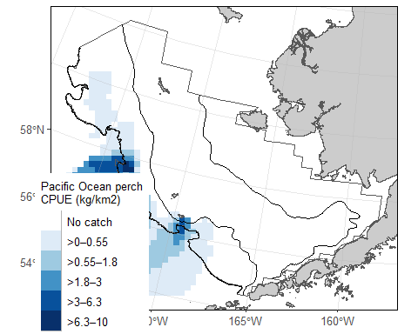
EBS Pacific Ocean perch CPUE and akgfmaps map.

8.0.6 Ex. GOA Pacific Ocean perch biomass and abundance
Biomass and abundance for Pacific Ocean perch from 1990 – 2023 for the western/central/eastern GOA management areas as well as for the entire region.
dat <- RODBC::sqlQuery(channel = channel,
query =
"
-- Manipulate data to join to
WITH FILTERED_STRATA AS (
SELECT AREA_ID, DESCRIPTION FROM GAP_PRODUCTS.AKFIN_AREA
WHERE AREA_TYPE in ('REGULATORY_AREA', 'REGION')
AND SURVEY_DEFINITION_ID = 47)
-- Select columns for output data
SELECT
BIOMASS_MT,
POPULATION_COUNT,
YEAR,
DESCRIPTION
-- Identify what tables to pull data from
FROM GAP_PRODUCTS.AKFIN_BIOMASS BIOMASS
JOIN FILTERED_STRATA STRATA
ON STRATA.AREA_ID = BIOMASS.AREA_ID
-- Filter data results
WHERE BIOMASS.SPECIES_CODE = 30060")
dat0 <- dat %>%
janitor::clean_names() %>%
dplyr::select(biomass_mt, population_count, year, area = description) %>%
pivot_longer(cols = c("biomass_mt", "population_count"),
names_to = "var",
values_to = "val") %>%
dplyr::mutate(
val = ifelse(var == "biomass_mt", val/1e6, val/1e9),
var = ifelse(var == "biomass_mt", "Biomass (Mmt)", "Population (B)"),
area = gsub(x = area, pattern = " - ", replacement = "\n"),
area = gsub(x = area, pattern = ": ", replacement = "\n"),
type = sapply(X = strsplit(x = area, split = "\n", fixed = TRUE), `[[`, 2)) %>%
dplyr::arrange(type) %>%
dplyr::mutate(
area = factor(area, levels = unique(area), labels = unique(area), ordered = TRUE))
flextable::flextable(head(dat)) %>%
flextable::fit_to_width(max_width = 6) %>%
flextable::theme_zebra() %>%
flextable::colformat_num(x = ., j = "YEAR", big.mark = "")
BIOMASS_MT | POPULATION_COUNT | YEAR | DESCRIPTION
157,295.1 | 317,129,408 | 1990 | GOA Region: All Strata
157,295.1 | 317,129,408 | 1990 | GOA Region: All Strata
483,622.6 | 833,902,161 | 1993 | GOA Region: All Strata
483,622.6 | 833,902,161 | 1993 | GOA Region: All Strata
771,412.8 | 1,252,616,603 | 1996 | GOA Region: All Strata
771,412.8 | 1,252,616,603 | 1996 | GOA Region: All Strata
# install.packages("scales")
library(scales)
figure <- ggplot2::ggplot(
dat = dat0,
mapping = aes(x = year, y = val, color = type)) +
ggplot2::geom_point(size = 3) +
ggplot2::facet_grid(cols = vars(area), rows = vars(var), scales = "free_y") +
ggplot2::scale_x_continuous(name = "Year", n.breaks = 3) +
ggplot2::scale_y_continuous(name = "Estimate", labels = comma) +
ggplot2::labs(title = 'GOA Pacific Ocean perch biomass and abundance 1990 – 2023') +
ggplot2::guides(color=guide_legend(title = "Region Type"))+
ggplot2::scale_color_grey() +
ggplot2::theme_bw() +
ggplot2::theme(legend.direction = "horizontal",
legend.position = "bottom")
figure
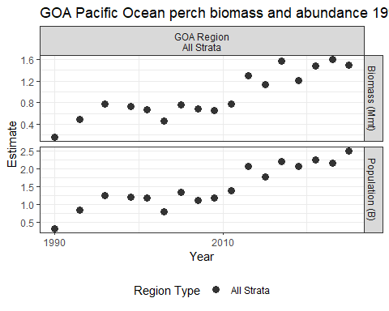
GOA Pacific Ocean perch biomass and abundance.

8.0.7 Ex. AI rock sole size compositions and ridge plot
Northern and Southern rock sole size composition data from 1991 – 2022 for the Aleutian Islands, with Ridge plot from ggridges.
dat <- RODBC::sqlQuery(channel = channel,
query = "
SELECT
YEAR,
LENGTH_MM / 10 AS LENGTH_CM,
SUM(POPULATION_COUNT) AS POPULATION_COUNT
-- Identify what tables to pull data from
FROM GAP_PRODUCTS.AKFIN_SIZECOMP
-- 99904 is the AREA_ID that codes for the whole AI survey region
WHERE AREA_ID = 99904
-- including northern rock sole, southern rock sole, and rock sole unid.
AND SPECIES_CODE IN (10260, 10261, 10262)
-- remove the -9 LENGTH_MM code
AND LENGTH_MM > 0
-- sum over species_codes and sexes
GROUP BY (YEAR, LENGTH_MM)")
dat0 <- dat %>%
janitor::clean_names() %>%
head() %>%
flextable::flextable() %>%
flextable::fit_to_width(max_width = 6) %>%
flextable::theme_zebra() %>%
flextable::colformat_num(x = ., j = "year", big.mark = "")
dat0
year | length_cm | population_count
1991 | 23 | 4,625,236
1991 | 38 | 2,254,964
1991 | 42 | 820,614
1991 | 52 | 11,225
1994 | 16 | 741,246
1994 | 26 | 9,762,322
# install.packages("ggridges")
library(ggridges)
figure <- ggplot(dat,
mapping = aes(x = LENGTH_CM,
y = YEAR,
height = POPULATION_COUNT,
group = YEAR)) +
ggridges::geom_density_ridges(stat = "identity", scale = 1) +
ggplot2::ylab(label = "Year") +
ggplot2::scale_x_continuous(name = "Length (cm)") +
ggplot2::labs(title = paste0('Aleutian Islands Rock sole Size Compositions'),
subtitle = paste0(min(dat$YEAR), ' – ', max(dat$YEAR))) +
ggplot2::theme_bw()
figure
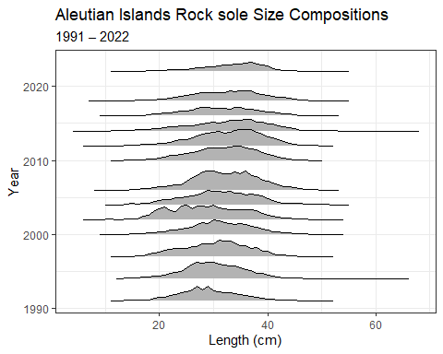
AI Rock sole size compositions and ridge plot.

8.0.8 Ex. 2023 EBS Walleye Pollock Age Compositions and Age Pyramid
Walleye pollock age composition for the EBS standard + NW Area from 2023, with age pyramid plot.
dat <- RODBC::sqlQuery(channel = channel,
query = "
-- Manipulate data to join to
WITH FILTERED_STRATA AS (
SELECT
AREA_ID,
DESCRIPTION
FROM GAP_PRODUCTS.AKFIN_AREA
WHERE AREA_TYPE = 'REGION' AND
SURVEY_DEFINITION_ID = 98)
-- Select columns for output data
SELECT
AGECOMP.AGE,
AGECOMP.POPULATION_COUNT,
AGECOMP.SEX
-- Identify what tables to pull data from
FROM GAP_PRODUCTS.AKFIN_AGECOMP AGECOMP
JOIN FILTERED_STRATA STRATA
ON STRATA.AREA_ID = AGECOMP.AREA_ID
-- Filter data results
WHERE SPECIES_CODE = 21740
AND YEAR = 2023
AND AGE >= 0")
dat0 <- dat %>%
janitor::clean_names() %>%
dplyr::filter(sex %in% c(1,2)) %>%
dplyr::mutate(
sex = ifelse(sex == 1, "M", "F"),
population_count = # change male population to negative
ifelse(sex=="M", population_count*(-1), population_count*1)/1e9)
flextable::flextable(head(dat)) %>%
flextable::fit_to_width(max_width = 6) %>%
flextable::theme_zebra()
AGE | POPULATION_COUNT | SEX
1 | 22,107,475 | 1
2 | 123,357,791 | 1
3 | 136,795,032 | 1
4 | 253,072,637 | 1
5 | 967,413,018 | 1
6 | 242,965,335 | 1
figure <- ggplot2::ggplot(
data = dat0,
mapping =
aes(x = age,
y = population_count,
fill = sex)) +
ggplot2::scale_fill_grey() +
ggplot2::geom_bar(stat = "identity") +
ggplot2::coord_flip() +
ggplot2::scale_x_continuous(name = "Age") +
ggplot2::scale_y_continuous(name = "Population (billions)", labels = abs) +
ggplot2::ggtitle(label = "2023 EBS Walleye Pollock Age Compositions") +
ggplot2::guides(fill = guide_legend(title = "Sex"))+
ggplot2::theme_bw()
figure
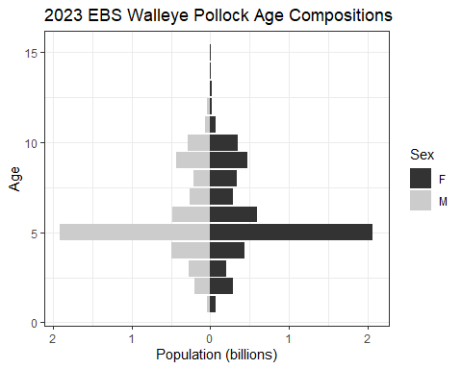
2023 EBS Walleye Pollock Age Compositions and Age Pyramid.

8.0.9 Ex. NBS Pacific cod biomass and abundance
Pacific cod biomass and abundance data for the NBS by stratum.
dat <- RODBC::sqlQuery(channel = channel,
query =
"
-- Manipulate data to join to
WITH FILTERED_STRATA AS (
SELECT
AREA_ID,
AREA_NAME,
DESCRIPTION
FROM GAP_PRODUCTS.AKFIN_AREA
WHERE AREA_TYPE in ('STRATUM') AND
SURVEY_DEFINITION_ID = 143)
-- Select columns for output data
SELECT
BIOMASS.BIOMASS_MT,
BIOMASS.POPULATION_COUNT,
BIOMASS.YEAR,
STRATA.AREA_NAME
-- Identify what tables to pull data from
FROM GAP_PRODUCTS.AKFIN_BIOMASS BIOMASS
JOIN FILTERED_STRATA STRATA
ON STRATA.AREA_ID = BIOMASS.AREA_ID
-- Filter data results
WHERE BIOMASS.SURVEY_DEFINITION_ID IN 143
AND BIOMASS.SPECIES_CODE = 21720")
dat0 <- dat %>%
janitor::clean_names() %>%
dplyr::select(biomass_mt, population_count, year, area = area_name) %>%
pivot_longer(cols = c("biomass_mt", "population_count"),
names_to = "var",
values_to = "val") %>%
dplyr::mutate(
val = ifelse(var == "biomass_mt", val/1e6, val/1e9),
var = ifelse(var == "biomass_mt", "Biomass (Mmt)", "Population (B)"),
area = factor(area, levels = unique(area), labels = unique(area), ordered = TRUE))
flextable::flextable(head(dat)) %>%
flextable::fit_to_width(max_width = 6) %>%
flextable::theme_zebra() %>%
flextable::colformat_num(x = ., j = "YEAR", big.mark = "")
BIOMASS_MT | POPULATION_COUNT | YEAR | AREA_NAME
7,462.559 | 4,724,153 | 2010 | Inner Domain
132,490.152 | 66,187,245 | 2017 | Inner Domain
107,096.730 | 102,734,142 | 2019 | Inner Domain
95,849.983 | 68,767,498 | 2021 | Inner Domain
96,500.697 | 60,433,135 | 2022 | Inner Domain
76,708.433 | 39,605,860 | 2023 | Inner Domain
figure <- ggplot2::ggplot(
dat = dat0,
mapping = aes(y = val, x = year, fill = area)) +
ggplot2::geom_bar(position="stack", stat="identity") +
ggplot2::facet_grid(rows = vars(var), scales = "free_y") +
ggplot2::scale_y_continuous(name = "Estimate", labels = comma) +
ggplot2::scale_x_continuous(name = "Year", breaks = unique(dat0$year)) +
ggplot2::labs(title = 'NBS Pacific cod biomass and abundance by stratum') +
ggplot2::guides(fill=guide_legend(title = "Region Type"))+
ggplot2::scale_fill_grey() +
ggplot2::theme_bw() +
ggplot2::theme(legend.direction = "horizontal",
legend.position = "bottom")
figure
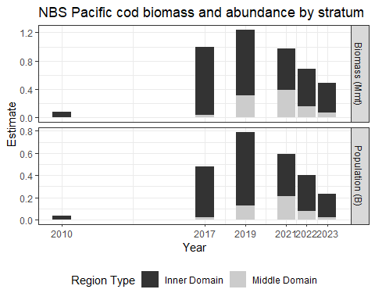
NBS Pacific cod biomass and abundance.

8.0.10 Ex. GOA Pacific Ocean perch biomass and line plot
Pacific Ocean perch biomass totals for GOA between 1984-2021 from GAP_PRODUCTS.AKFIN_BIOMASS
dat <- RODBC::sqlQuery(channel = channel,
query = "
-- Select columns for output data
SELECT
SURVEY_DEFINITION_ID,
BIOMASS_MT / 1000 AS BIOMASS_KMT,
(BIOMASS_MT - 2 * SQRT(BIOMASS_VAR)) / 1000 AS BIOMASS_KCI_DW,
(BIOMASS_MT + 2 * SQRT(BIOMASS_VAR)) / 1000 AS BIOMASS_KCI_UP,
YEAR
-- Identify what tables to pull data from
FROM GAP_PRODUCTS.AKFIN_BIOMASS
-- Filter data results
WHERE SPECIES_CODE = 30060
AND SURVEY_DEFINITION_ID = 47
AND AREA_ID = 99903
AND YEAR BETWEEN 1990 AND 2023" ) %>%
janitor::clean_names()
flextable::flextable(head(dat)) %>%
flextable::fit_to_width(max_width = 6) %>%
flextable::theme_zebra() %>%
flextable::colformat_num(x = ., j = "year", big.mark = "")
survey_definition_id | biomass_kmt | biomass_kci_dw | biomass_kci_up | year
47 | 157.2951 | 63.03638 | 251.5538 | 1990
47 | 483.6226 | 266.33581 | 700.9093 | 1993
47 | 771.4128 | 364.30515 | 1,178.5204 | 1996
47 | 764.9014 | 471.64517 | 1,058.1577 | 2005
47 | 688.1798 | 459.83542 | 916.5241 | 2007
47 | 457.4216 | 313.39204 | 601.4511 | 2003
a_mean <- dat %>%
dplyr::group_by(survey_definition_id) %>%
dplyr::summarise(biomass_kmt = mean(biomass_kmt, na.rm = TRUE),
minyr = min(year, na.rm = TRUE),
maxyr = max(year, na.rm = TRUE))
figure <-
ggplot(data = dat,
mapping = aes(x = year,
y = biomass_kmt)) +
ggplot2::geom_point(size = 2.5, color = "grey40") +
ggplot2::scale_x_continuous(
name = "Year",
labels = scales::label_number(
accuracy = 1,
big.mark = "")) +
ggplot2::scale_y_continuous(
name = "Biomass (Kmt)",
labels = comma) +
ggplot2::geom_segment(
data = a_mean,
mapping = aes(x = minyr,
xend = maxyr,
y = biomass_kmt,
yend = biomass_kmt),
linetype = "dashed",
linewidth = 2) +
ggplot2::geom_errorbar(
mapping = aes(ymin = biomass_kci_dw, ymax = biomass_kci_up),
position = position_dodge(.9),
alpha = 0.5, width=.2) +
ggplot2::ggtitle(
label = "GOA Pacific Ocean Perch Biomass 1984-2021",
subtitle = paste0("Mean = ",
formatC(x = a_mean$biomass_kmt,
digits = 2,
big.mark = ",",
format = "f"),
" Kmt")) +
ggplot2::theme_bw()
figure
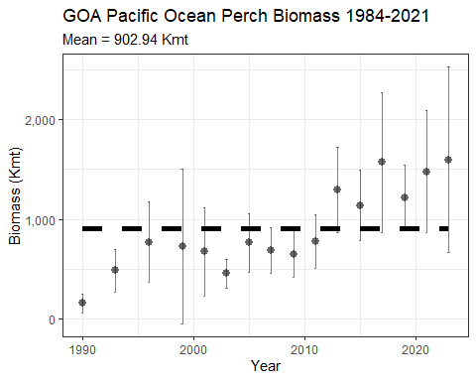
GOA Pacific Ocean perch biomass and line plot.

8.0.11 Ex. 2022 AI Atka mackerel age specimen summary

8.0.11.1 All ages determined:
dat <- RODBC::sqlQuery(channel = channel,
query = "
-- Select columns for output data
SELECT SURVEY_DEFINITION_ID, YEAR, SPECIES_CODE, AGE
-- Identify what tables to pull data from
FROM GAP_PRODUCTS.AKFIN_SPECIMEN
JOIN (SELECT HAULJOIN, CRUISEJOIN FROM GAP_PRODUCTS.AKFIN_HAUL)
USING (HAULJOIN)
JOIN (SELECT CRUISEJOIN, YEAR, SURVEY_DEFINITION_ID FROM GAP_PRODUCTS.AKFIN_CRUISE)
USING (CRUISEJOIN)
-- Filter data results
WHERE GAP_PRODUCTS.AKFIN_SPECIMEN.SPECIMEN_SAMPLE_TYPE = 1
AND SPECIES_CODE = 21921
AND YEAR = 2022
AND SURVEY_DEFINITION_ID = 52") %>%
janitor::clean_names()
flextable::flextable(head(dat) %>%
dplyr::arrange(age)) %>%
flextable::fit_to_width(max_width = 6) %>%
flextable::theme_zebra() %>%
flextable::colformat_num(x = ., j = c("year", "species_code"), big.mark = "")
survey_definition_id | year | species_code | age
52 | 2022 | 21921 | 3
52 | 2022 | 21921 | 3
52 | 2022 | 21921 | 4
52 | 2022 | 21921 | 4
52 | 2022 | 21921 | 4
52 | 2022 | 21921 | 7

8.0.11.2 How many of each age was found:
dat <- RODBC::sqlQuery(channel = channel,
query = "
-- Select columns for output data
SELECT SURVEY_DEFINITION_ID, YEAR, SPECIES_CODE, AGE,
COUNT(AGE) AS COUNTAGE
-- Identify what tables to pull data from
FROM GAP_PRODUCTS.AKFIN_SPECIMEN
JOIN (SELECT HAULJOIN, CRUISEJOIN FROM GAP_PRODUCTS.AKFIN_HAUL)
USING (HAULJOIN)
JOIN (SELECT CRUISEJOIN, YEAR, SURVEY_DEFINITION_ID FROM GAP_PRODUCTS.AKFIN_CRUISE)
USING (CRUISEJOIN)
-- Filter data results
WHERE GAP_PRODUCTS.AKFIN_SPECIMEN.SPECIMEN_SAMPLE_TYPE = 1
AND SPECIES_CODE = 21921
AND YEAR = 2022
AND SURVEY_DEFINITION_ID = 52
GROUP BY (YEAR, SURVEY_DEFINITION_ID, SPECIES_CODE, AGE)") %>%
janitor::clean_names()
flextable::flextable(head(dat) %>%
dplyr::arrange(age)) %>%
flextable::fit_to_width(max_width = 6) %>%
flextable::theme_zebra() %>%
flextable::colformat_num(x = ., j = c("year", "species_code"), big.mark = "")
survey_definition_id | year | species_code | age | countage
52 | 2022 | 21921 | 1 | 1
52 | 2022 | 21921 | 2 | 40
52 | 2022 | 21921 | 6 | 116
52 | 2022 | 21921 | 7 | 108
52 | 2022 | 21921 | 8 | 61
52 | 2022 | 21921 | 11 | 20

8.0.11.3 How many otoliths were aged:
Using SQL
dat <- RODBC::sqlQuery(channel = channel,
query = "
-- Select columns for output data
SELECT SURVEY_DEFINITION_ID, YEAR, SPECIES_CODE,
COUNT(AGE) AS COUNTAGE
-- Identify what tables to pull data from
FROM GAP_PRODUCTS.AKFIN_SPECIMEN
JOIN (SELECT HAULJOIN, CRUISEJOIN FROM GAP_PRODUCTS.AKFIN_HAUL)
USING (HAULJOIN)
JOIN (SELECT CRUISEJOIN, YEAR, SURVEY_DEFINITION_ID FROM GAP_PRODUCTS.AKFIN_CRUISE)
USING (CRUISEJOIN)
-- Filter data results
WHERE GAP_PRODUCTS.AKFIN_SPECIMEN.SPECIMEN_SAMPLE_TYPE = 1
AND SPECIES_CODE = 21921
AND YEAR = 2022
AND SURVEY_DEFINITION_ID = 52
GROUP BY (YEAR, SURVEY_DEFINITION_ID, SPECIES_CODE)") %>%
janitor::clean_names()
Using dbplyr:
library(odbc)
library(keyring)
library(dplyr)
library(dbplyr)
channel <- DBI::dbConnect(odbc::odbc(), "akfin", uid = keyring::key_list("akfin")$username,
pwd = keyring::key_get("akfin", keyring::key_list("akfin")$username))
dat <- dplyr::tbl(src = channel, dplyr::sql('gap_products.akfin_specimen')) %>%
dplyr::rename_all(tolower) %>%
dplyr::select(hauljoin, specimen = specimen_id, species_code, length = length_mm,
weight = weight_g, age, sex, age_method = age_determination_method) %>%
dplyr::left_join(dplyr::tbl(akfin, dplyr::sql('gap_products.akfin_haul')) %>%
dplyr::rename_all(tolower) %>%
dplyr::select(cruisejoin, hauljoin, haul, date_collected = date_time_start,
latitude = latitude_dd_start, longitude = longitude_dd_start),
by = join_by(hauljoin)) %>%
dplyr::left_join(dplyr::tbl(akfin, dplyr::sql('gap_products.akfin_cruise')) %>%
dplyr::rename_all(tolower) %>%
dplyr::select(cruisejoin, year, vessel = vessel_id, survey_definition_id),
by = join_by(cruisejoin)) %>%
dplyr::filter(year == YEAR &
survey_definition_id == 52 &
species_code %in% spp_codes &
!is.na(age)) %>%
dplyr::collect()
Both scripts will produce this table:
flextable::flextable(head(dat)) %>%
flextable::fit_to_width(max_width = 6) %>%
flextable::theme_zebra() %>%
flextable::colformat_num(x = ., j = c("year", "species_code"), big.mark = "")
survey_definition_id | year | species_code | countage
52 | 2022 | 21921 | 1,061

9. Access API data using R
AKFIN has developed web services (apis) to distribute GAP data. Like the GAP_PRODUCTS schema, these are under active development. These do not require VPN or an oracle connection but they are protected by Oracle authentication, please contact matt.callahan@noaa.gov for information on how to get an api token to use this option.
The url structure is “https://apex.psmfc.org/akfin/data_marts/gap_products/gap_[base table name]” . For example “https://apex.psmfc.org/akfin/data_marts/gap_products/gap_biomass” is the base url to get data from the akfin_biomass table. Web services linked to large tables have mandatory parameters to reduce data download size. For example to get agecomp data for Bering Sea pollock in area_id 10 in 2022 you would use “https://apex.psmfc.org/akfin/data_marts/gap_products/gap_biomass?survey_definition_id=98&area_id=10&species_code=21740&start_year=2022&end_year=2022”.
If you’re using R to pull data through web services you might find the akfingapdata (pronounced akfin-gap-data not ak-eff-ing-app-data) R package helpful.
# load libraries
library(dplyr)
library(magrittr)
library(httr)
library(flextable)
# tell R to not use scientific notation
options(scipen=999)
# function for pulling data from the api using the httr package
get_gap_biomass<-function(area_id, species_code) {
# paste(... collapse=",") puts commas between vector elements
area_id <- paste(area_id, collapse = ",")
species_code <- paste(species_code, collapse = ",")
# httr code, parameters are after the '?'
httr::content(
httr::GET(paste0("https://apex.psmfc.org/akfin/data_marts/akmp/gap_biomass?area_id=",
area_id,
"&species_code=",
species_code)),
type = "application/json") %>%
# convert to data frame
bind_rows()
}

9.1 Ex. Direct database query in R using the (akfingapdata readme)[https://github.com/MattCallahan-NOAA/akfingapdata/blob/main/README.Rmd] R package:
# load packages
library(odbc)
library(getPass)
library(tidyverse)
# connect to AKFIN Oracle database
con <- dbConnect(odbc::odbc(), "akfin", UID=getPass(msg="USER NAME"), PWD=getPass())
# define species code for pollock
my_species <- 21740
#query database
data<- dbFetch(dbSendQuery(con,
paste0("select * from gap_products.akfin_biomass
where species_name = ", my_species,
" and survey_definition_id = 98,
and area_id = 10"))) %>%
rename_with(tolower) # everyone likes lower case letters better
head(data)

9.2 Ex. Direct database query in R using the (akfingapdata readme)[https://github.com/MattCallahan-NOAA/akfingapdata/blob/main/README.Rmd] R package:
library(akfingapdata)
# Sign into akfin with token (need to request token from AKFIN)
token <- akfingapdata::create_token(file = paste0(dirname(here::here()), "/akfin_token.txt"))
akfingapdata::get_gap_catch()[,1:6] %>%
head() %>%
flextable::flextable() %>%
flextable::theme_zebra()
cruisejoin | hauljoin | catchjoin | species_code | weight_kg | count
-611 | -13,626 | -374,397 | 21,740 | 189.590 | 450
-611 | -13,632 | -374,643 | 21,740 | 134.830 | 151
-611 | -13,501 | -370,283 | 21,740 | 32.060 | 44
-611 | -13,545 | -371,701 | 21,740 | 1,154.024 | 1,345
-611 | -13,577 | -372,795 | 21,740 | 963.070 | 1,273
-611 | -13,677 | -376,146 | 21,740 | 1,618.589 | 2,814

10. Data description
The Resource Assessment and Conservation Engineering Division (RACE) Groundfish Assessment Program (GAP) of the Alaska Fisheries Science Center (AFSC) conducts fisheries-independent bottom trawl surveys to monitor the condition of the demersal fish and crab stocks of Alaska. These data are developed to describe the temporal distribution and abundance of commercially and ecologically important groundfish species, examine the changes in the species composition of the fauna over time and space, and describe the physical environment of the groundfish habitat.
There are no legal restrictions on access to the data. They reside in the public domain and can be freely distributed. Users must read and fully comprehend the metadata prior to use. Data should not be used beyond the limits of the source scale. Acknowledgement of NOAA, as the source from which these data were obtained, in any publications and/or other representations of these data, is suggested. These data are compiled and approved annually after each summer survey season. The data from previous years are unlikely to change substantially once published.
These data are zero-filled (presence and absence) observations from surveys conducted on fishing vessels. These surveys monitor trends in distribution and abundance of groundfish, crab, and bottom-dwelling species in Alaska’s marine ecosystems. These data include estimates of catch-per-unit-effort (CPUE) for all identified species for index stations. Some survey data are excluded, such as non-standard stations, surveys completed in earlier years using different/non-standard gear, and special tows and non-standard data collections.
Though not included in the public data, these surveys also collect oceanographic and environmental data, and biological data such as length, weight, stomach contents (to learn more about diet), otoliths (fish ear bones to learn about age), and tissue samples for genetic analysis, all of which can be shared upon special request. Also not included in the public data are estimated biomass (average total weight of all fish and crabs sampled) of crabs and groundfish that support the creation of annual stock assessments.

10.1 Data tables

10.1.1 FOSS_CATCH
These datasets, FOSS_CATCH, FOSS_CPUE_PRESONLY, FOSS_HAUL, and FOSS_SPECIES, when full joined by the HAULJOIN variable, includes zero-filled (presence and absence) observations and catch-per-unit-effort (CPUE) estimates for all identified species at for index stations. These tables were created by the Resource Assessment and Conservation Engineering Division (RACE) Groundfish Assessment Program (GAP) of the Alaska Fisheries Science Center (AFSC). There are legal restrictions on access to the data. These data are not intended for public dissemination and should not be shared without the explicit written consent of the data managers and owners (NOAA Fisheries). The GitHub repository for the scripts that created this code can be found at https://github.com/afsc-gap-products/gap_products. For more information about codes used in the tables, please refer to the survey code books (https://www.fisheries.noaa.gov/resource/document/groundfish-survey-species-code-manual-and-data-codes-manual). These data were last updated March 04, 2024.
Number of rows: 939,197
Number of columns: 7
Column name from data
Descriptive column Name
Units
Oracle data type
Column description
COUNT
Taxon count
count, whole number resolution
NUMBER(38,0)
Total whole number of individuals caught in haul or samples collected.
CPUE_KGKM2
Weight CPUE (kg/km2)
kilograms per kilometers squared
NUMBER(38,6)
Catch weight (kilograms) per unit effort (area swept by the net, units square kilometers).
CPUE_NOKM2
Number CPUE (no/km2)
count per kilometers squared
NUMBER(38,6)
Numerical catch per unit effort (area swept by the net, units square kilometers).
HAULJOIN
Haul ID
ID key code
NUMBER(38,0)
This is a unique numeric identifier assigned to each (vessel, cruise, and haul) combination.
SPECIES_CODE
Taxon code
ID key code
NUMBER(38,0)
The species code of the organism associated with the ‘common_name’ and ‘scientific_name’ columns. For a complete species list, review the code books.
TAXON_CONFIDENCE
Taxon confidence rating
category
VARCHAR2(255 BYTE)
Confidence in the ability of the survey team to correctly identify the taxon to the specified level, based solely on identification skill (e.g., not likelihood of a taxon being caught at that station on a location-by-location basis). Quality codes follow: ‘High’: High confidence and consistency. Taxonomy is stable and reliable at this level, and field identification characteristics are well known and reliable. ‘Moderate’: Moderate confidence. Taxonomy may be questionable at this level, or field identification characteristics may be variable and difficult to assess consistently. ‘Low’: Low confidence. Taxonomy is incompletely known, or reliable field identification characteristics are unknown. Documentation: Species identification confidence in the eastern Bering Sea shelf survey (1982-2008), Species identification confidence in the eastern Bering Sea slope survey (1976-2010), and Species identification confidence in the Gulf of Alaska and Aleutian Islands surveys (1980-2011).
WEIGHT_KG
Sample or taxon weight (kg)
kilograms
NUMBER(38,3)
Weight (thousandths of a kilogram) of individuals in a haul by taxon.

10.1.2 FOSS_HAUL
These datasets, FOSS_CATCH, FOSS_CPUE_PRESONLY, FOSS_HAUL, and FOSS_SPECIES, when full joined by the HAULJOIN variable, includes zero-filled (presence and absence) observations and catch-per-unit-effort (CPUE) estimates for all identified species at for index stations. These tables were created by the Resource Assessment and Conservation Engineering Division (RACE) Groundfish Assessment Program (GAP) of the Alaska Fisheries Science Center (AFSC). There are legal restrictions on access to the data. These data are not intended for public dissemination and should not be shared without the explicit written consent of the data managers and owners (NOAA Fisheries). The GitHub repository for the scripts that created this code can be found at https://github.com/afsc-gap-products/gap_products. For more information about codes used in the tables, please refer to the survey code books (https://www.fisheries.noaa.gov/resource/document/groundfish-survey-species-code-manual-and-data-codes-manual). These data were last updated March 04, 2024.
Number of rows: 33,334
Number of columns: 27
Column name from data
Descriptive column Name
Units
Oracle data type
Column description
AREA_SWEPT_KM2
Area swept (km)
kilometers
NUMBER(38,6)
The area the net covered while the net was fishing (kilometers squared), defined as the distance fished times the net width.
BOTTOM_TEMPERATURE_C
Bottom temperature (degrees Celsius)
degrees Celsius
NUMBER(38,1)
Bottom temperature (tenths of a degree Celsius); NA indicates removed or missing values.
CRUISE
Cruise Name
ID key code
NUMBER(38,0)
This is a six-digit integer identifying the cruise number of the form: YYYY99 (where YYYY = year of the cruise; 99 = 2-digit number and is sequential; 01 denotes the first cruise that vessel made in this year, 02 is the second, etc.).
CRUISEJOIN
Cruise ID
ID key code
NUMBER(38,0)
Unique integer ID assigned to each survey, vessel, and year combination.
DATE_TIME
Date and time
MM/DD/YYYY HH::MM
DATE
The date (MM/DD/YYYY) and time (HH:MM) of the haul. All dates and times are in Alaska time (AKDT) of Anchorage, AK, USA (UTC/GMT -8 hours).
DEPTH_M
Depth (m)
degrees Celsius
NUMBER(38,1)
Bottom depth (meters).
DISTANCE_FISHED_KM
Distance fished (km)
degrees Celsius
NUMBER(38,3)
Distance the net fished (thousands of kilometers).
DURATION_HR
Tow duration (decimal hr)
hours
NUMBER(38,1)
This is the elapsed time between start and end of a haul (decimal hours).
HAUL
Haul number
ID key code
NUMBER(38,0)
This number uniquely identifies a sampling event (haul) within a cruise. It is a sequential number, in chronological order of occurrence.
HAULJOIN
Haul ID
ID key code
NUMBER(38,0)
This is a unique numeric identifier assigned to each (vessel, cruise, and haul) combination.
LATITUDE_DD_END
End latitude (decimal degrees)
decimal degrees
NUMBER(38,6)
Latitude (one hundred thousandth of a decimal degree) of the end of the haul.
LATITUDE_DD_START
Start latitude (decimal degrees)
decimal degrees
NUMBER(38,6)
Latitude (one hundred thousandth of a decimal degree) of the start of the haul.
LONGITUDE_DD_END
End longitude (decimal degrees)
decimal degrees
NUMBER(38,6)
Longitude (one hundred thousandth of a decimal degree) of the end of the haul.
LONGITUDE_DD_START
Start longitude (decimal degrees)
decimal degrees
NUMBER(38,6)
Longitude (one hundred thousandth of a decimal degree) of the start of the haul.
NET_HEIGHT_M
Net height (m)
meters
NUMBER(38,1)
Measured or estimated distance (meters) between footrope and headrope of the trawl.
NET_WIDTH_M
Net width (m)
meters
NUMBER(38,1)
Measured or estimated distance (meters) between wingtips of the trawl.
PERFORMANCE
Haul performance code
category
NUMBER(38,0)
This denotes what, if any, issues arose during the haul. For more information, review the code books.
SRVY
Survey abbreviation
text abbreviated
VARCHAR2(255 BYTE)
Abbreviated survey names. The column ‘srvy’ is associated with the ‘survey’ and ‘survey_definition_id’ columns. Northern Bering Sea (NBS), Southeastern Bering Sea (EBS), Bering Sea Slope (BSS), Gulf of Alaska (GOA), Aleutian Islands (AI).
STATION
Station ID
ID key code
VARCHAR2(255 BYTE)
Alpha-numeric designation for the station established in the design of a survey.
STRATUM
Stratum ID
ID key code
NUMBER(10,0)
RACE database statistical area for analyzing data. Strata were designed using bathymetry and other geographic and habitat-related elements. The strata are unique to each survey region. Stratum of value 0 indicates experimental tows.
SURFACE_TEMPERATURE_C
Surface temperature (degrees Celsius)
degrees Celsius
NUMBER(38,1)
Surface temperature (tenths of a degree Celsius); NA indicates removed or missing values.
SURVEY
Survey name
text
VARCHAR2(255 BYTE)
Name and description of survey. The column ‘survey’ is associated with the ‘srvy’ and ‘survey_definition_id’ columns.
SURVEY_DEFINITION_ID
Survey ID
ID key code
NUMBER(38,0)
The survey definition ID key code uniquely identifies a survey/survey design. Integer code that uniquely identifies survey. Full list of survey definition IDs are in RACE_DATA.SURVEY_DEFINITIONS. IDs used in GAP_PRODUCTS are: 47 (Gulf of Alaska); 52 (Aleutian Islands); 78 (Bering Sea Slope); 98 (Eastern Bering Sea Shelf); 143 (Northern Bering Sea Shelf). The column ‘survey_definition_id’ is associated with the ‘srvy’ and ‘survey’ columns. For a complete list of surveys, review the code books.
SURVEY_NAME
Survey name official
text
VARCHAR2(255 BYTE)
Long name of the survey conducted
VESSEL_ID
Vessel ID
ID key code
NUMBER(38,0)
ID number of the vessel used to collect data for that haul. The column ‘vessel_id’ is associated with the ‘vessel_name’ column. Note that it is possible for a vessel to have a new name but the same vessel id number. For a complete list of vessel ID key codes, review the code books.
VESSEL_NAME
Vessel name
text
VARCHAR2(255 BYTE)
Name of the vessel used to collect data for that haul. The column ‘vessel_name’ is associated with the ‘vessel_id’ column. Note that it is possible for a vessel to have a new name but the same vessel id number. For a complete list of vessel ID key codes, review the code books.
YEAR
Survey year
year
NUMBER(10,0)
Year the observation (survey) was collected.

10.1.3 FOSS_SPECIES
These datasets, FOSS_CATCH, FOSS_CPUE_PRESONLY, FOSS_HAUL, and FOSS_SPECIES, when full joined by the HAULJOIN variable, includes zero-filled (presence and absence) observations and catch-per-unit-effort (CPUE) estimates for all identified species at for index stations. These tables were created by the Resource Assessment and Conservation Engineering Division (RACE) Groundfish Assessment Program (GAP) of the Alaska Fisheries Science Center (AFSC). There are legal restrictions on access to the data. These data are not intended for public dissemination and should not be shared without the explicit written consent of the data managers and owners (NOAA Fisheries). The GitHub repository for the scripts that created this code can be found at https://github.com/afsc-gap-products/gap_products. For more information about codes used in the tables, please refer to the survey code books (https://www.fisheries.noaa.gov/resource/document/groundfish-survey-species-code-manual-and-data-codes-manual). These data were last updated March 04, 2024.
Number of rows: 1,894
Number of columns: 6
Column name from data
Descriptive column Name
Units
Oracle data type
Column description
COMMON_NAME
Taxon common name
text
VARCHAR2(255 BYTE)
The common name of the marine organism associated with the ‘scientific_name’ and ‘species_code’ columns. For a complete species list, review the code books.
ID_RANK
Lowest taxonomic rank
text
VARCHAR2(255 BYTE)
Lowest taxonomic rank of a given species entry.
ITIS
Integrated taxonomic information system (ITIS) serial number
ID key code
NUMBER(38,0)
Species code as identified in the Integrated Taxonomic Information System (https://itis.gov/).
SCIENTIFIC_NAME
Taxon scientific name
text
VARCHAR2(255 BYTE)
The scientific name of the organism associated with the ‘common_name’ and ‘species_code’ columns. For a complete taxon list, review the code books.
SPECIES_CODE
Taxon code
ID key code
NUMBER(38,0)
The species code of the organism associated with the ‘common_name’ and ‘scientific_name’ columns. For a complete species list, review the code books.
WORMS
World register of marine species (WoRMS) taxonomic serial number
ID key code
NUMBER(38,0)
Species code as identified in the World Register of Marine Species (WoRMS) (https://www.marinespecies.org/).

10.1.4 FOSS_SURVEY_SPECIES
This reference dataset contains the full list of species by survey to be used to zero-fill FOSS_CATCH and FOSS_HAUL for each survey. These tables were created by the Resource Assessment and Conservation Engineering Division (RACE) Groundfish Assessment Program (GAP) of the Alaska Fisheries Science Center (AFSC). There are legal restrictions on access to the data. These data are not intended for public dissemination and should not be shared without the explicit written consent of the data managers and owners (NOAA Fisheries). The GitHub repository for the scripts that created this code can be found at https://github.com/afsc-gap-products/gap_products. For more information about codes used in the tables, please refer to the survey code books (https://www.fisheries.noaa.gov/resource/document/groundfish-survey-species-code-manual-and-data-codes-manual). These data were last updated March 04, 2024.
Number of rows: 5,030
Number of columns: 2
Column name from data
Descriptive column Name
Units
Oracle data type
Column description
SPECIES_CODE
Taxon code
ID key code
NUMBER(38,0)
The species code of the organism associated with the ‘common_name’ and ‘scientific_name’ columns. For a complete species list, review the code books.
SURVEY_DEFINITION_ID
Survey ID
ID key code
NUMBER(38,0)
The survey definition ID key code uniquely identifies a survey/survey design. Integer code that uniquely identifies survey. Full list of survey definition IDs are in RACE_DATA.SURVEY_DEFINITIONS. IDs used in GAP_PRODUCTS are: 47 (Gulf of Alaska); 52 (Aleutian Islands); 78 (Bering Sea Slope); 98 (Eastern Bering Sea Shelf); 143 (Northern Bering Sea Shelf). The column ‘survey_definition_id’ is associated with the ‘srvy’ and ‘survey’ columns. For a complete list of surveys, review the code books.

10.1.5 FOSS_TAXON_GROUP
This reference dataset contains suggested search groups for simplifying species selection in the FOSS data platform so users can better search through FOSS_CATCH. These tables were created by the Resource Assessment and Conservation Engineering Division (RACE) Groundfish Assessment Program (GAP) of the Alaska Fisheries Science Center (AFSC). There are legal restrictions on access to the data. These data are not intended for public dissemination and should not be shared without the explicit written consent of the data managers and owners (NOAA Fisheries). The GitHub repository for the scripts that created this code can be found at https://github.com/afsc-gap-products/gap_products. For more information about codes used in the tables, please refer to the survey code books (https://www.fisheries.noaa.gov/resource/document/groundfish-survey-species-code-manual-and-data-codes-manual). These data were last updated March 04, 2024.
Number of rows: 33,721
Number of columns: 3
Column name from data
Descriptive column Name
Units
Oracle data type
Column description
CLASSIFICATION
Taxonomic classification rank group
category
VARCHAR2(255 BYTE)
Phylogenetic classification group rank for a given species.
RANK_ID
Taxonomic rank
category
VARCHAR2(255 BYTE)
The taxonomic rank of a taxon identification.
SPECIES_CODE
Taxon code
ID key code
NUMBER(38,0)
The species code of the organism associated with the ‘common_name’ and ‘scientific_name’ columns. For a complete species list, review the code books.

11. Using the FOSS platform

11.1 Select and filter
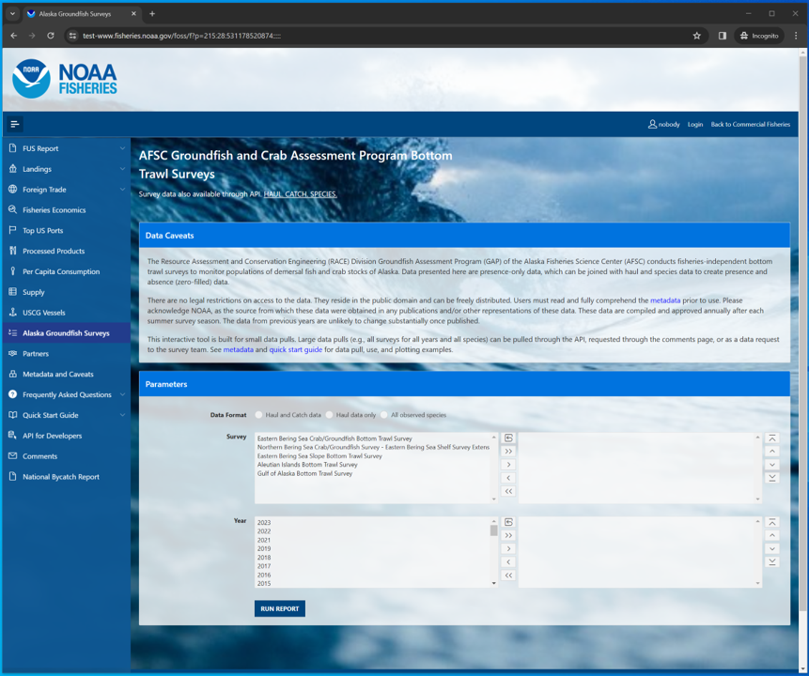
AFSC Groundfish and Crab Assessment Program Bottom Trawl Survey data interface on the Fisheries One Stop Shop platform.
Select, filter, and download this and other NOAA Fisheries data from the Fisheries One Stop Shop (FOSS) platform. A user guide for the FOSS platform can be found here. To begin a report, select the kind of data you need: Haul and catch data, Haul data only, All observed species.
In this example, we’ll select for 2023 eastern Bering Sea Arctic cod data. Here, we used the Search Species box to search for species with the term “cod” in their common names and selected “Pacific cod” from that shortened list.

11.1.1 Catch and haul
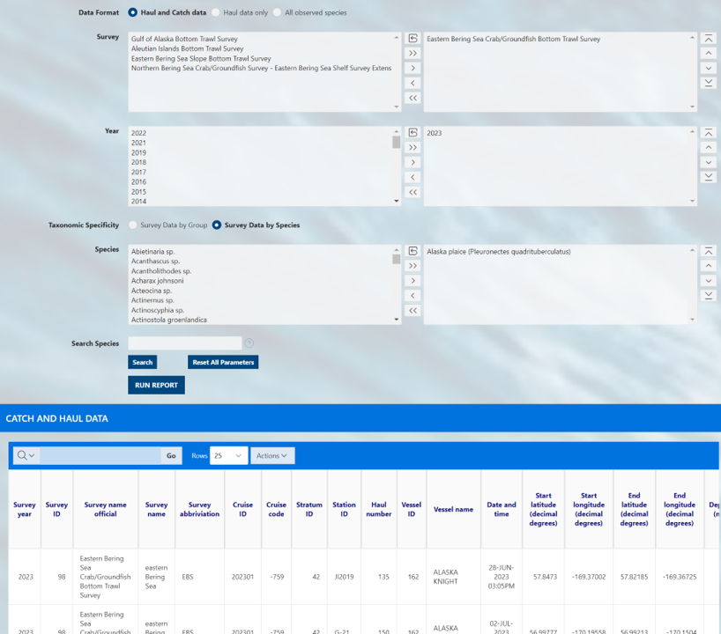
Catch data on the AFSC Groundfish and Crab Assessment Program Bottom Trawl Survey data interface on the Fisheries One Stop Shop platform.

11.1.2 Haul
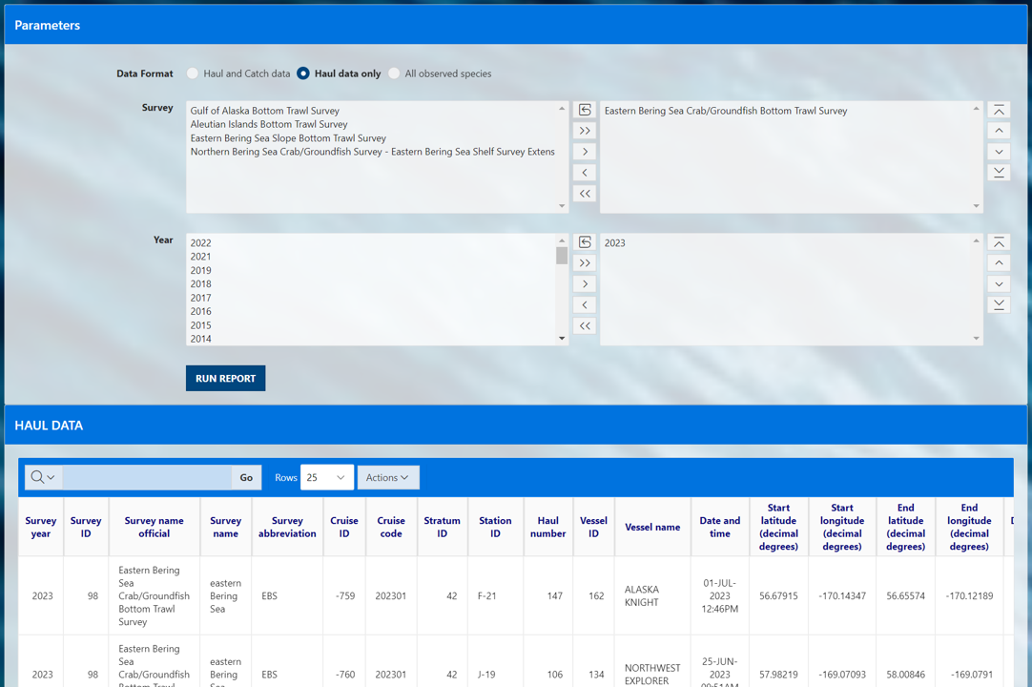
Haul data on the AFSC Groundfish and Crab Assessment Program Bottom Trawl Survey data interface on the Fisheries One Stop Shop platform.

11.1.3 Species
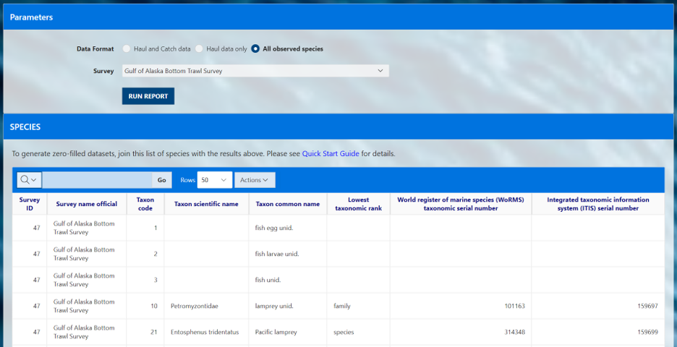
All species observed by survey on the AFSC Groundfish and Crab Assessment Program Bottom Trawl Survey data interface on the Fisheries One Stop Shop platform.

11.2 Search options
The user must select a option in each of the three option boxes as they appear for catch, haul, and species:
- Survey: Each survey has different in design, time series, and history. More information on each survey and their designs can be found in our annual data reports.
- Year: Surveys are not conducted in all years, so only data from the years for which the survey was conducted will be returned.
- Species: Common name of all species ever encountered in the survey. Find more information about these species in our survey code books.
For a given box, select one or a few options from the options box (list on the left) to query. To select multiple options, hold down the CTRL key while clicking on the options of interest, or click and drag down the list. Once the options you wish to be included in your query are highlighted, click the right-pointing arrow (>) to move them into the “selection box” (list on the right). This can also be achieved by double clicking the option item of interest. If you accidentally select an option that you do not want to query, simply select the unwanted option from the selection box and click the left-pointing arrow (<).
If you wish to select all options from the options box and send them to the selection box, simply click the double right-pointing arrow (>>). If you want to unselect all options from the selection box, use the double left-pointing arrow (<<) or the reset icon.
To find a specific species or group more quickly you can use the Search Species option to quickly narrow the options. Search for parts of species common names in the Search Species box by entering a term and clicking the search button. The platform will return a shorter list in the Speices options box of only species that contain a match to that search term.
Use the Reset All Parameters button to reset all parameters for entire form.
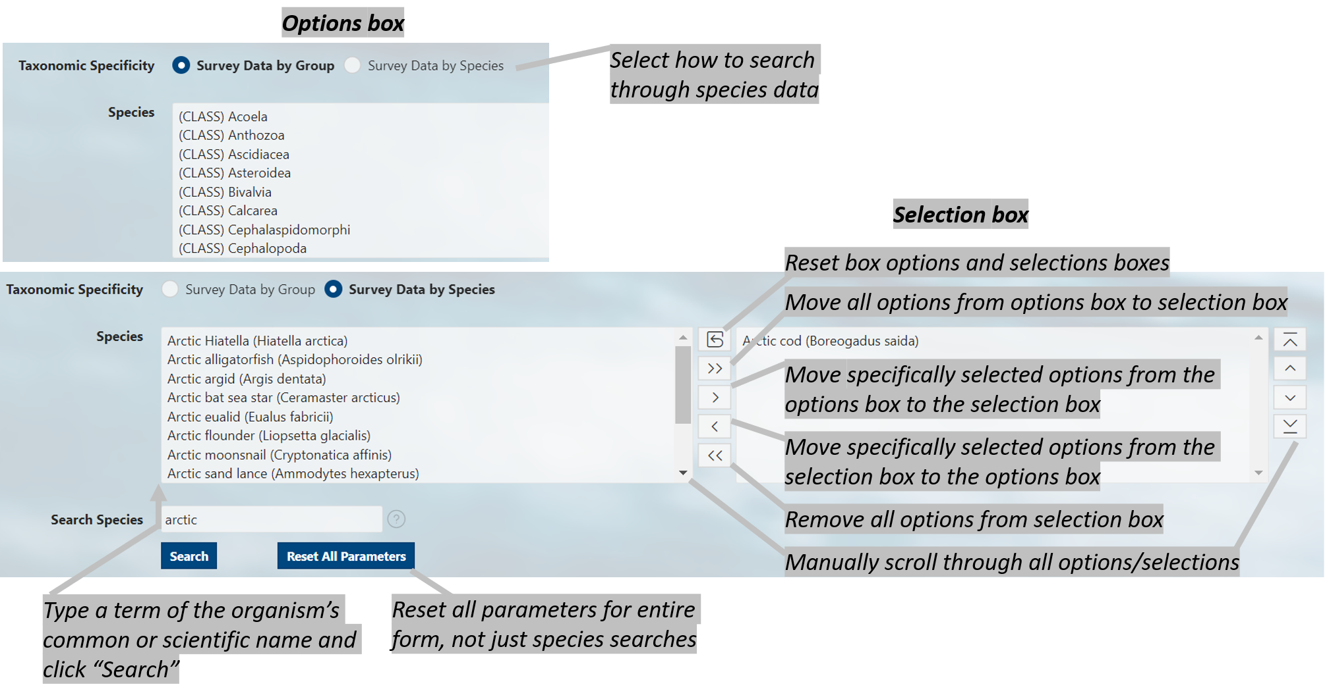
Diagram of selection and search tools available on the FOSS platfrom.

11.3 Run report
Click the RUN REPORT button. Below the select and filter area, the results of your query will appear below the page in the format you selected. To change the format, make a different selection and run the report again. Further modifications to your results can be made by clicking on the Actions button above your data. Here you can download your data, select columns included in your results, and apply a variety of filters and mathematical tools.
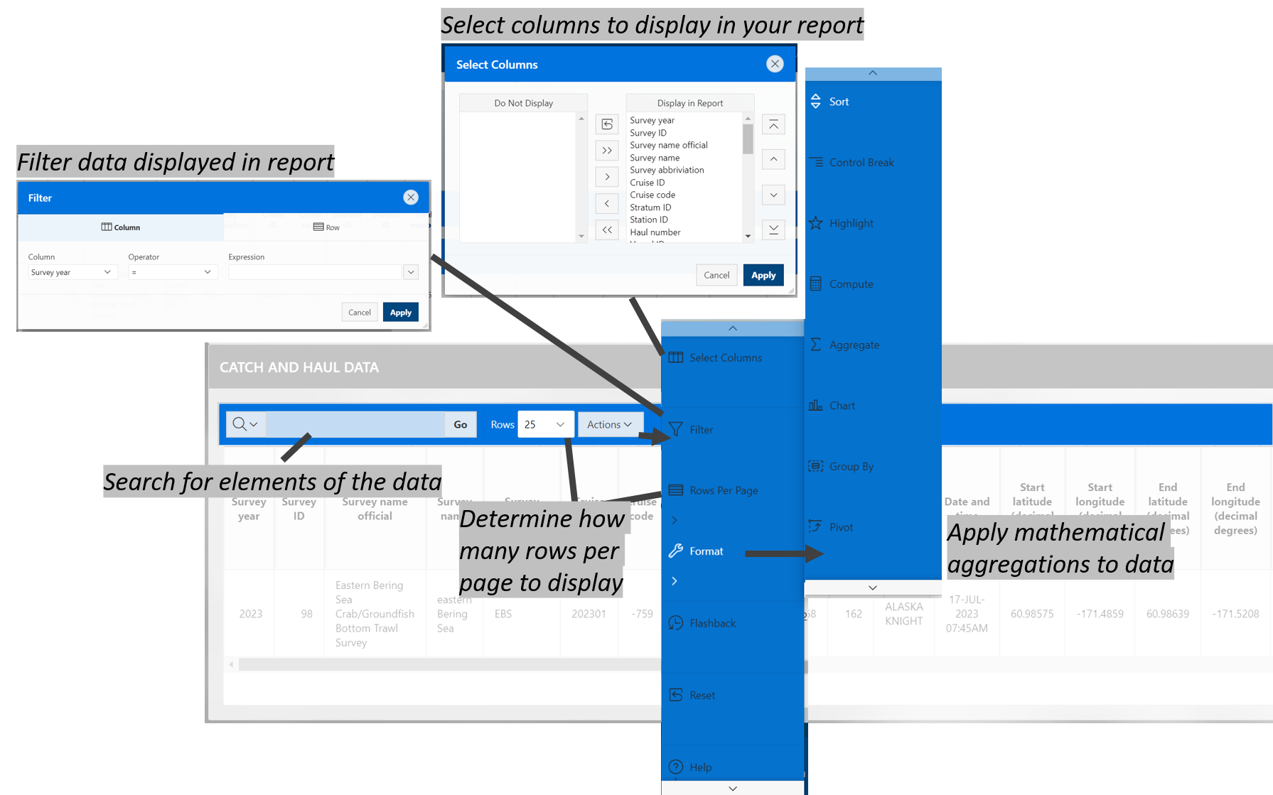
Example data returned from running the report.

11.4 API
APIs, or Application Programming Interfaces, allows users to pull data through a IDE, or integrated development environment, like RStudio or VS Code. Explore the API pages for each of the data pages (Haul and catch data, Haul data only, All observed species).

12. Use data
Learn how to pull and use this data through the
- API and R programming language
- API and python programming language using the afscgap python package
- Oracle and R programming language (AFSC scientists only)

13. Access via API and R
An application programming interface (API) is a way for two or more computer programs to communicate with each other.
More information about how to amend API links can be found here. Useful introductions to using APIs in R can be found here.

13.1 Ex. Load the first 25 rows (default) of data
# install.packages(c("httr", "jsonlite"))
library(httr)
library(jsonlite)
library(dplyr)
# link to the API
api_link <- "https://apps-st.fisheries.noaa.gov/ods/foss/afsc_groundfish_survey/"
res <- httr::GET(url = api_link)
# res # Test connection
data <- jsonlite::fromJSON(base::rawToChar(res$content))
# names(data)
tibble::as_tibble(data$items) %>%
dplyr::mutate_if(is.character, type.convert, as.is = TRUE) %>%
dplyr::mutate(across(where(is.numeric), round, 3)) %>%
head(3) %>%
flextable::flextable() %>%
flextable::theme_zebra() %>%
flextable::colformat_num(x = ., j = c("year", "cruise", "species_code", "tsn", "ak_survey_id"), big.mark = "")
year | srvy | survey | survey_id | cruise | haul | stratum | station | vessel_name | vessel_id | date_time | latitude_dd | longitude_dd | species_code | common_name | scientific_name | taxon_confidence | cpue_kgha | cpue_kgkm2 | cpue_kg1000km2 | cpue_noha | cpue_nokm2 | cpue_no1000km2 | weight_kg | count | bottom_temperature_c | surface_temperature_c | depth_m | distance_fished_km | net_width_m | net_height_m | area_swept_ha | duration_hr | tsn | ak_survey_id | links
2002 | AI | Aleutian Islands Bottom Trawl Survey | 52 | 200201 | 6 | 722 | 307-63 | Vesteraalen | 94 | 05/17/2002 18:56:58 | 53.737 | -167.016 | 95020 | feathery bryozoan | Eucratea loricata | Low | 0.017 | 1.749 | 1,749.445 |  |  |  | 0.044 | 0 | 4.1 | 5.3 | 187 | 1.561 | 16.112 | 7.25 | 2.515 | 0.28 | 155809 | 1917453 | [[data.frame]]
2002 | AI | Aleutian Islands Bottom Trawl Survey | 52 | 200201 | 6 | 722 | 307-63 | Vesteraalen | 94 | 05/17/2002 18:56:58 | 53.737 | -167.016 | 79000 | squid unid. | Decapodiformes | High | 0.022 | 2.227 | 2,226.567 | 3.181 | 318.081 | 318,080.93 | 0.056 | 8 | 4.1 | 5.3 | 187 | 1.561 | 16.112 | 7.25 | 2.515 | 0.28 |  | 1917454 | [[data.frame]]
2002 | AI | Aleutian Islands Bottom Trawl Survey | 52 | 200201 | 6 | 722 | 307-63 | Vesteraalen | 94 | 05/17/2002 18:56:58 | 53.737 | -167.016 | 24191 | shortfin eelpout | Lycodes brevipes | High | 0.036 | 3.578 | 3,578.410 | 0.795 | 79.520 | 79,520.23 | 0.090 | 2 | 4.1 | 5.3 | 187 | 1.561 | 16.112 | 7.25 | 2.515 | 0.28 | 165258 | 1917455 | [[data.frame]]
# install.packages(c("httr", "jsonlite"))
library(httr)
library(jsonlite)
library(dplyr)
# link to the API
api_link <- "https://apps-st.fisheries.noaa.gov/ods/foss/afsc_groundfish_survey/"
res <- httr::GET(url = api_link)
# res # Test connection
data <- jsonlite::fromJSON(base::rawToChar(res$content))
# names(data)
tibble::as_tibble(data$items) %>%
dplyr::mutate_if(is.character, type.convert, as.is = TRUE) %>%
dplyr::mutate(across(where(is.numeric), round, 3)) %>%
head(3) %>%
flextable::flextable() %>%
flextable::theme_zebra() %>%
flextable::colformat_num(x = ., j = c("year", "cruise", "species_code", "tsn", "ak_survey_id"), big.mark = "")
year | srvy | survey | survey_id | cruise | haul | stratum | station | vessel_name | vessel_id | date_time | latitude_dd | longitude_dd | species_code | common_name | scientific_name | taxon_confidence | cpue_kgha | cpue_kgkm2 | cpue_kg1000km2 | cpue_noha | cpue_nokm2 | cpue_no1000km2 | weight_kg | count | bottom_temperature_c | surface_temperature_c | depth_m | distance_fished_km | net_width_m | net_height_m | area_swept_ha | duration_hr | tsn | ak_survey_id | links
2002 | AI | Aleutian Islands Bottom Trawl Survey | 52 | 200201 | 6 | 722 | 307-63 | Vesteraalen | 94 | 05/17/2002 18:56:58 | 53.737 | -167.016 | 95020 | feathery bryozoan | Eucratea loricata | Low | 0.017 | 1.749 | 1,749.445 |  |  |  | 0.044 | 0 | 4.1 | 5.3 | 187 | 1.561 | 16.112 | 7.25 | 2.515 | 0.28 | 155809 | 1917453 | [[data.frame]]
2002 | AI | Aleutian Islands Bottom Trawl Survey | 52 | 200201 | 6 | 722 | 307-63 | Vesteraalen | 94 | 05/17/2002 18:56:58 | 53.737 | -167.016 | 79000 | squid unid. | Decapodiformes | High | 0.022 | 2.227 | 2,226.567 | 3.181 | 318.081 | 318,080.93 | 0.056 | 8 | 4.1 | 5.3 | 187 | 1.561 | 16.112 | 7.25 | 2.515 | 0.28 |  | 1917454 | [[data.frame]]
2002 | AI | Aleutian Islands Bottom Trawl Survey | 52 | 200201 | 6 | 722 | 307-63 | Vesteraalen | 94 | 05/17/2002 18:56:58 | 53.737 | -167.016 | 24191 | shortfin eelpout | Lycodes brevipes | High | 0.036 | 3.578 | 3,578.410 | 0.795 | 79.520 | 79,520.23 | 0.090 | 2 | 4.1 | 5.3 | 187 | 1.561 | 16.112 | 7.25 | 2.515 | 0.28 | 165258 | 1917455 | [[data.frame]]

13.2 Ex. Load the first 10,000 rows of data
# Not run because too big:
res <- httr::GET(url = paste0(api_link, "?offset=0&limit=10000"))
data <- jsonlite::fromJSON(base::rawToChar(res$content))
print(paste0("rows: ", dim(data$items)[1], "; cols: ", dim(data$items)[2]))
[1] "rows: 10000; cols: 36"

13.3 Ex. Filter by Year
Show all the data greater than the year 2020.
res <- httr::GET(url = paste0(api_link, '?q={"year":{"$gt":2020}}'))
data <- jsonlite::fromJSON(base::rawToChar(res$content))
as_tibble(data$items) %>%
mutate_if(is.character, type.convert, as.is = TRUE) %>%
head(3) %>%
dplyr::mutate(across(where(is.numeric), round, 3)) %>%
dplyr::select(year, srvy, stratum, species_code, cpue_kgkm2) %>%
flextable::flextable() %>%
flextable::fit_to_width(max_width = 6) %>%
flextable::theme_zebra() %>%
flextable::colformat_num(x = ., j = c("year", "species_code"), big.mark = "")
year | srvy | stratum | species_code | cpue_kgkm2
2022 | AI | 793 | 80540 | 0.361
2022 | AI | 793 | 401 | 0.903
2022 | AI | 793 | 20006 | 1.661

13.4 Ex. Filter by species name
Show all the data where the product name contains pollock Please note that here the word pollock is case sensitive.
The notation for finding a string is to use % around it. Since % is a reserved character in a URL, you have to replace % with %25.
res <- httr::GET(
url = paste0(api_link, '?q={"common_name":{"$like":"%25pollock%25"}}'))
data <- jsonlite::fromJSON(base::rawToChar(res$content))
as_tibble(data$items) %>%
mutate_if(is.character, type.convert, as.is = TRUE) %>%
head(3) %>%
dplyr::mutate(across(where(is.numeric), round, 3)) %>%
dplyr::select(year, srvy, stratum, species_code, cpue_kgkm2) %>%
flextable::flextable() %>%
flextable::fit_to_width(max_width = 6) %>%
flextable::theme_zebra() %>%
flextable::colformat_num(x = ., j = c("year", "species_code"), big.mark = "")
year | srvy | stratum | species_code | cpue_kgkm2
2002 | AI | 722 | 21740 | 775.322
2002 | AI | 722 | 21740 | 10,685.806
2002 | AI | 721 | 21740 | 0.640

13.5 Ex. Combination of year and name filters
Show all the data where years > 2020 and the product name contains pollock
res <- httr::GET(
url = paste0(api_link,
'?q={"year":{"$gt":2020},"common_name":{"$like":"%25pollock%25"}}'))
data <- jsonlite::fromJSON(base::rawToChar(res$content))
as_tibble(data$items) %>%
mutate_if(is.character, type.convert, as.is = TRUE) %>%
head(3) %>%
dplyr::mutate(across(where(is.numeric), round, 3)) %>%
dplyr::select(year, srvy, stratum, species_code, cpue_kgkm2) %>%
flextable::flextable() %>%
flextable::fit_to_width(max_width = 6) %>%
flextable::theme_zebra() %>%
flextable::colformat_num(x = ., j = c("year", "species_code"), big.mark = "")
year | srvy | stratum | species_code | cpue_kgkm2
2022 | AI | 793 | 21740 | 7,853.632
2022 | AI | 721 | 21740 | 7,235.010
2022 | AI | 722 | 21740 | 22,754.334

13.6 Ex. Combination of year, srvy, stratum
Show all the data where year = 1989, srvy = “EBS”, and stratum is not equal to 81
res <- httr::GET(
url = paste0(api_link, '?q={"year":1989,"srvy":"EBS","stratum":{"$ne":"81"}}'))
data <- jsonlite::fromJSON(base::rawToChar(res$content))
as_tibble(data$items) %>%
mutate_if(is.character, type.convert, as.is = TRUE) %>%
head(3) %>%
dplyr::mutate(across(where(is.numeric), round, 3)) %>%
dplyr::select(year, srvy, stratum, species_code, cpue_kgkm2) %>%
flextable::flextable() %>%
flextable::fit_to_width(max_width = 6) %>%
flextable::theme_zebra() %>%
flextable::colformat_num(x = ., j = c("year", "species_code"), big.mark = "")
year | srvy | stratum | species_code | cpue_kgkm2
1989 | EBS | 10 | 66548 | 1.164
1989 | EBS | 10 | 69322 | 1.164
1989 | EBS | 10 | 43000 | 2.353

13.7 Ex. Visualize CPUE data in distribution map
Pacific cod catch-per-unit-effort estimates for NBS in 2021 and map constructed using akgfmaps.
# res <- httr::GET(
# url = paste0(api_link, "?offset=0&limit=10000"),
# query = list(year = 2021, srvy = "EBS", species_code = 30060))
res <- httr::GET(
url = paste0(api_link, '?q={"year":2021,"srvy":"NBS","species_code":21720}'))
data_catch <- jsonlite::fromJSON(base::rawToChar(res$content))$items %>%
dplyr::select(stratum, station, cpue_kgkm2)
# zero-fill data (imperfectly, but effective for this example)
res <- httr::GET(
url = paste0(api_link, '?q={"year":2021,"srvy":"NBS"}offset=0&limit=10000'))
data_haul <- jsonlite::fromJSON(base::rawToChar(res$content))$items %>%
dplyr::select(stratum, station, latitude_dd, longitude_dd) %>%
dplyr::mutate(across(where(is.numeric), round, 3)) %>%
dplyr::distinct()
data <- dplyr::left_join(data_haul, data_catch) %>%
dplyr::mutate(cpue_kgkm2 = ifelse(is.na(cpue_kgkm2), 0, cpue_kgkm2),
dplyr::across(dplyr::everything(), as.numeric))
flextable::flextable(data[1:3,]) %>%
flextable::fit_to_width(max_width = 6) %>%
flextable::theme_zebra()
stratum | station | latitude_dd | longitude_dd | cpue_kgkm2
81 |  | 61.66434 | -172.2655 | 2,895.258
81 |  | 62.33740 | -173.1702 | 1,235.545
70 |  | 62.03713 | -171.6528 | 0.000
# devtools::install_github("afsc-gap-products/akgfmaps", build_vignettes = TRUE)
library(akgfmaps)
figure <- akgfmaps::make_idw_map(
CPUE_KGHA = data$cpue_kgkm2, # calculates the same, regardless of units.
LATITUDE = data$latitude_dd,
LONGITUDE = data$longitude_dd,
region = "bs.north", # Predefined EBS area
set.breaks = "jenks", # Gets Jenks breaks from classint::classIntervals()
in.crs = "+proj=longlat", # Set input coordinate reference system
out.crs = "EPSG:3338", # Set output coordinate reference system
grid.cell = c(20000, 20000))$plot + # 20x20km grid
ggplot2::guides(fill=guide_legend(title = "Pacific cod\nCPUE (kg/km2)"))
[inverse distance weighted interpolation]
[inverse distance weighted interpolation]
figure
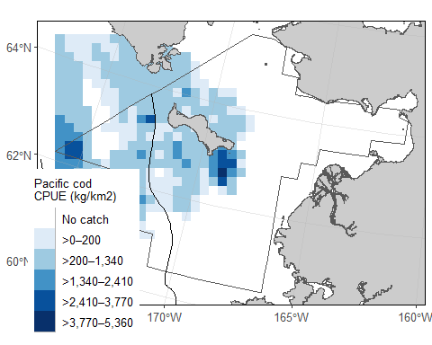
Visualize CPUE data in distribution map.

14. Access via API and Python

14.0.1 {afscgap} Library Installation
author: Sam Pottinger (sam.pottinger@berkeley.edu; GitHub::sampottinger) date: May 13, 2023
The third-party afscgap Python package interfaces with FOSS to access AFSC GAP data. It can be installed via pip:
#The reticulate package provides a comprehensive set of tools for interoperability between Python and R.
library(reticulate)
pip install afscgap
pip install git+https://github.com/SchmidtDSE/afscgap.git@main
For more information on installation and deployment, see the library documentation.

14.0.2 Basic query
This first example queries for Pacific glass shrimp (Pasiphaea pacifica) in the Gulf of Alaska in 2021. The library will automatically generate HTTP queries, converting from Python types to ORDS query syntax.
import afscgap
query = afscgap.Query()
query.filter_year(eq=2021)
query.filter_srvy(eq='GOA')
query.filter_scientific_name(eq='Pasiphaea pacifica')
results = query.execute()
The results variable in this example is an iterator that will automatically perform pagination behind the scenes.

14.0.3 Iterating with a for loop
The easiest way to interact with results is a simple for loop. This next example determines the frequency of different catch per unit effort where Pacific glass shrimp were reported:
import afscgap
# Mapping from CPUE to count
count_by_cpue = {}
# Build query
query = afscgap.Query()
query.filter_year(eq=2021)
query.filter_srvy(eq='GOA')
query.filter_scientific_name(eq='Pasiphaea pacifica')
results = query.execute()
# Iterate through results and count
for record in results:
cpue = record.get_cpue_weight(units='kg/ha')
cpue_rounded = round(cpue)
count = count_by_cpue.get(cpue_rounded, 0) + 1
count_by_cpue[cpue_rounded] = count
# Print the result
print(count_by_cpue)
Note that, in this example, only records with Pacific glass shrimp are included (“presence-only” data). See zero catch inference below. In other words, it reports on CPUE only for hauls in which Pacific glass shrimp were recorded, excluding some hauls like those in which Pacific glass shrimp were not found at all.

14.0.4 Iterating with functional programming
A for loop is not the only option for iterating through results. List comprehensions and other functional programming methods can be used as well.
import statistics
import afscgap
# Build query
query = afscgap.Query()
query.filter_year(eq=2021)
query.filter_srvy(eq='GOA')
query.filter_scientific_name(eq='Pasiphaea pacifica')
results = query.execute()
# Get temperatures in Celsius
temperatures = [record.get_bottom_temperature(units='c') for record in results]
# Take the median
print(statistics.median(temperatures))
This example reports the median temperature in Celcius for when Pacific glass shrimp was reported.

14.0.5 Load into Pandas
The results from the afscgap package are serializable and can be loaded into other tools like Pandas. This example loads Pacific glass shrimp from 2021 Gulf of Alaska into a data frame.
import pandas
import afscgap
query = afscgap.Query()
query.filter_year(eq=2021)
query.filter_srvy(eq='GOA')
query.filter_scientific_name(eq='Pasiphaea pacifica')
results = query.execute()
pandas.DataFrame(results.to_dicts())
Specifically, to_dicts provides an iterator over a dictionary form of the data that can be read into tools like Pandas.

14.0.6 Advanced filtering
Queries so far have focused on filters requiring equality but range queries can be built as well.
import afscgap
# Build query
query = afscgap.Query()
query.filter_year(min_val=2015, max_val=2019) # Note min/max_val
query.filter_srvy(eq='GOA')
query.filter_scientific_name(eq='Pasiphaea pacifica')
results = query.execute()
# Sum weight
weights = map(lambda x: x.get_weight(units='kg'), results)
total_weight = sum(weights)
print(total_weight)
This example queries for Pacific glass shrimp data between 2015 and 2019, summing the total weight caught. Note that most users will likely take advantage of built-in Python to ORDS query generation which dictates how the library communicates with the API service. However, users can provide raw ORDS queries as well using manual filtering.

14.0.7 Zero-catch inference
Until this point, these examples use presence-only data. However, the afscgap package can infer negative or “zero catch” records as well.
import afscgap
# Mapping from CPUE to count
count_by_cpue = {}
# Build query
query = afscgap.Query()
query.filter_year(eq=2021)
query.filter_srvy(eq='GOA')
query.filter_scientific_name(eq='Pasiphaea pacifica')
query.set_presence_only(False) # Added to earlier example
results = query.execute()
# Iterate through results and count
for record in results:
cpue = record.get_cpue_weight(units='kg/ha')
cpue_rounded = round(cpue)
count = count_by_cpue.get(cpue_rounded, 0) + 1
count_by_cpue[cpue_rounded] = count
# Print the result
print(count_by_cpue)
This example revisits the earlier snippet for CPUE counts but set_presence_only(False) directs the library to look at additional data on hauls, determining which hauls did not have Pacific glass shrimp. This lets the library return records for hauls in which Pacific glass shrimp were not found. This can be seen in differences in counts reported:
Rounded CPUE | Count with set_presence_only(True) | Count with set_presence_only(False)
0 kg/ha | 44 | 521
1 kg/ha | 7 | 7
2 kg/ha | 1 | 1
Put simply, while the earlier example showed CPUE counts for hauls in which Pacific glass shrimp were seen, this revised example reports for all hauls in the Gulf of Alaska in 2021.

14.0.8 More information
Please see the API documentation for the Python library for additional details.

15. Access via Oracle and R (AFSC only)
If the user has access to the AFSC Oracle database, the user can use SQL developer to view and pull the FOSS public data directly from the GAP_PRODUCTS Oracle schema.

15.0.1 Connect to Oracle from R
Many users will want to access the data from Oracle using R. The user will need to install the RODBC R package and ask OFIS (IT) connect R to Oracle. Then, use the following code in R to establish a connection from R to Oracle:
Here, the user can write in their username and password directly into the RODBC connect function. Never save usernames or passwords in scripts that may be intentionally or unintentionally shared with others. If no username and password is entered in the function, pop-ups will appear on the screen asking for the username and password.
library(gapindex)
channel <- gapindex::get_connected()

15.0.2 Ex. Wholesale download data and join data in R
locations <- c(
"GAP_PRODUCTS.FOSS_CATCH",
"GAP_PRODUCTS.FOSS_HAUL",
"GAP_PRODUCTS.FOSS_SPECIES"
)
print(Sys.Date())
error_loading <- c() # log if any tables are unable to download
for (i in 1:length(locations)){
print(locations[i])
a <- RODBC::sqlQuery(channel, paste0("SELECT * FROM ", locations[i], "; "))
if (is.null(nrow(a))) { # if an error in downloading has occurred
error_loading <- c(error_loading, locations[i])
} else { # if no error in downloading has occurred
write.csv(x = a,
# change file name to be more computer file storage friendly
here::here(paste0(tolower(gsub(
pattern = '.',
replacement = "_",
x = locations[i],
fixed = TRUE)),
".csv")))
}
}
error_loading
Join downloaded files into presence-only table
# Load data
library(dplyr)
library(here)
library(readr)
catch <- readr::read_csv(file = here::here("data/gap_products_foss_catch.csv"))[,-1] # remove "row number" column
haul <- readr::read_csv(file = here::here("data/gap_products_foss_haul.csv"))[,-1] # remove "row number" column
species <- readr::read_csv(file = here::here("data/gap_products_foss_species.csv"))[,-1] # remove "row number" column
dat <-
# join haul and catch data to unique species by survey table
dplyr::left_join(haul, catch) %>%
# join species data to unique species by survey table
dplyr::left_join(species) %>%
# modify zero-filled rows
dplyr::mutate(
CPUE_KGKM2 = ifelse(is.null(CPUE_KGKM2), 0, CPUE_KGKM2), # just in case
CPUE_KGHA = CPUE_KGKM2/100, # Hectares
CPUE_NOKM2 = ifelse(is.null(CPUE_NOKM2), 0, CPUE_NOKM2), # just in case
CPUE_NOHA = CPUE_NOKM2/100, # Hectares
COUNT = ifelse(is.null(COUNT), 0, COUNT),
WEIGHT_KG = ifelse(is.null(WEIGHT_KG), 0, WEIGHT_KG) )
Join downloaded files into zero-filled table
# Load data
library(dplyr)
library(here)
library(readr)
catch <- readr::read_csv(file = here::here("data/gap_products_foss_catch.csv"))[,-1] # remove "row number" column
haul <- readr::read_csv(file = here::here("data/gap_products_foss_haul.csv"))[,-1] # remove "row number" column
species <- readr::read_csv(file = here::here("data/gap_products_foss_species.csv"))[,-1] # remove "row number" column
# come up with full combination of what species should be listed for what hauls/surveys
# for zero-filled data, all species caught in a survey need to have zero or non-zero row entries for a haul
comb <- dplyr::full_join(
x = dplyr::left_join(catch, haul, by = "HAULJOIN") %>%
dplyr::select(SURVEY_DEFINITION_ID, SPECIES_CODE) %>%
dplyr::distinct(),
y = haul %>%
dplyr::select(SURVEY_DEFINITION_ID, HAULJOIN) %>%
dplyr::distinct(),
by = "SURVEY_DEFINITION_ID",
relationship = "many-to-many"
)
# Join data to make a full zero-filled CPUE dataset
dat <- comb %>%
# add species data to unique species by survey table
dplyr::left_join(species, "SPECIES_CODE") %>%
# add catch data
dplyr::full_join(catch, c("SPECIES_CODE", "HAULJOIN")) %>%
# add haul data
dplyr::full_join(haul) %>% # , c("SURVEY_DEFINITION_ID", "HAULJOIN")
# modify zero-filled rows
dplyr::mutate(
CPUE_KGKM2 = ifelse(is.null(CPUE_KGKM2), 0, CPUE_KGKM2),
CPUE_KGHA = CPUE_KGKM2/100, # Hectares
CPUE_NOKM2 = ifelse(is.null(CPUE_NOKM2), 0, CPUE_NOKM2),
CPUE_NOHA = CPUE_NOKM2/100, # Hectares
COUNT = ifelse(is.null(COUNT), 0, COUNT),
WEIGHT_KG = ifelse(is.null(WEIGHT_KG), 0, WEIGHT_KG) )

15.0.3 Ex. Join data using Oracle
To join these tables in Oracle, you may use a variant of the following code:
SELECT
hh.YEAR,
hh.SRVY,
hh.SURVEY,
hh.SURVEY_DEFINITION_ID,
hh.SURVEY_NAME,
hh.CRUISE,
hh.CRUISEJOIN,
hh.HAUL,
hh.HAULJOIN,
hh.STRATUM,
hh.STATION,
hh.VESSEL_ID,
hh.VESSEL_NAME,
hh.DATE_TIME,
hh.LATITUDE_DD_START,
hh.LONGITUDE_DD_START,
hh.LATITUDE_DD_END,
hh.LONGITUDE_DD_END,
hh.BOTTOM_TEMPERATURE_C,
hh.SURFACE_TEMPERATURE_C,
hh.DEPTH_M,
cc.SPECIES_CODE,
ss.ITIS,
ss.WORMS,
ss.COMMON_NAME,
ss.SCIENTIFIC_NAME,
ss.ID_RANK,
CASE WHEN cc.CPUE_KGKM2 IS NULL THEN 0 ELSE cc.CPUE_KGKM2 END AS CPUE_KGKM2,
CASE WHEN cc.CPUE_NOKM2 IS NULL THEN 0 ELSE cc.CPUE_NOKM2 END AS CPUE_NOKM2,
CASE WHEN cc.COUNT IS NULL THEN 0 ELSE cc.COUNT END AS COUNT,
CASE WHEN cc.WEIGHT_KG IS NULL THEN 0 ELSE cc.WEIGHT_KG END AS WEIGHT_KG,
CASE WHEN cc.TAXON_CONFIDENCE IS NULL THEN NULL ELSE cc.TAXON_CONFIDENCE END AS TAXON_CONFIDENCE,
hh.AREA_SWEPT_KM2,
hh.DISTANCE_FISHED_KM,
hh.DURATION_HR,
hh.NET_WIDTH_M,
hh.NET_HEIGHT_M,
hh.PERFORMANCE
FROM GAP_PRODUCTS.FOSS_SURVEY_SPECIES sv
FULL OUTER JOIN GAP_PRODUCTS.FOSS_SPECIES ss
ON sv.SPECIES_CODE = ss.SPECIES_CODE
FULL OUTER JOIN GAP_PRODUCTS.FOSS_HAUL hh
ON sv.SURVEY_DEFINITION_ID = hh.SURVEY_DEFINITION_ID
FULL OUTER JOIN GAP_PRODUCTS.FOSS_CATCH cc
ON sv.SPECIES_CODE = cc.SPECIES_CODE
AND hh.HAULJOIN = cc.HAULJOIN

15.0.4 Ex. Subset data
Here, we are pulling EBS Pacific cod from 2010 - 2021:
# Pull data
data <- RODBC::sqlQuery(
channel = channel,
query =
"SELECT * FROM GAP_PRODUCTS.FOSS_CATCH cc
JOIN GAP_PRODUCTS.FOSS_HAUL hh
ON cc.HAULJOIN = hh.HAULJOIN
WHERE SRVY = 'EBS'
AND SPECIES_CODE = 21720 -- 'Pacific cod'
AND YEAR >= 2010
AND YEAR < 2021")
flextable::flextable(data[1:3,]) %>%
flextable::theme_zebra()
HAULJOIN | SPECIES_CODE | CPUE_KGKM2 | CPUE_NOKM2 | COUNT | WEIGHT_KG | TAXON_CONFIDENCE | YEAR | SRVY | SURVEY | SURVEY_DEFINITION_ID | SURVEY_NAME | CRUISE | CRUISEJOIN | HAULJOIN.1 | HAUL | STRATUM | STATION | VESSEL_ID | VESSEL_NAME | DATE_TIME | LATITUDE_DD_START | LONGITUDE_DD_START | LATITUDE_DD_END | LONGITUDE_DD_END | BOTTOM_TEMPERATURE_C | SURFACE_TEMPERATURE_C | DEPTH_M | DISTANCE_FISHED_KM | DURATION_HR | NET_WIDTH_M | NET_HEIGHT_M | AREA_SWEPT_KM2 | PERFORMANCE
-19,288 | 21,720 | 449.8301 | 1,876.1759 | 83 | 19.90 | 1 | 2,019 | EBS | eastern Bering Sea | 98 | Eastern Bering Sea Crab/Groundfish Bottom Trawl Survey | 201,901 | -727 | -19,288 | 96 | 20 | O-18 | 162 | ALASKA KNIGHT | 2019-06-29 06:54:00 | 59.68079 | -168.6144 | 59.65546 | -168.6178 | 5.1 | 7.8 | 39 | 2.821 | 0.505 | 15.682 | 2.227 | 0.044239 | 0
-19,252 | 21,720 | 413.4828 | 248.0897 | 12 | 20.00 | 1 | 2,019 | EBS | eastern Bering Sea | 98 | Eastern Bering Sea Crab/Groundfish Bottom Trawl Survey | 201,901 | -727 | -19,252 | 76 | 31 | G-03 | 162 | ALASKA KNIGHT | 2019-06-24 15:52:02 | 57.01591 | -166.4752 | 56.99137 | -166.4601 | 4.1 | 9.7 | 74 | 2.880 | 0.528 | 16.795 | 2.126 | 0.048370 | 0
-18,731 | 21,720 | 946.3481 | 2,592.1327 | 118 | 43.08 | 1 | 2,019 | EBS | eastern Bering Sea | 98 | Eastern Bering Sea Crab/Groundfish Bottom Trawl Survey | 201,901 | -726 | -18,731 | 11 | 31 | I-13 | 94 | VESTERAALEN | 2019-06-04 13:15:57 | 57.69052 | -160.2580 | 57.66518 | -160.2640 | 5.5 | 7.5 | 54 | 2.840 | 0.520 | 16.029 | 2.200 | 0.045522 | 0

15.0.5 Ex. Find all species found in the eastern Bering Sea (EBS) survey in 2023
# Pull data
data <- RODBC::sqlQuery(
channel = channel,
query =
"SELECT DISTINCT
ss.COMMON_NAME,
ss.SCIENTIFIC_NAME,
ss.ID_RANK,
ss.WORMS
FROM GAP_PRODUCTS.FOSS_CATCH cc -- get species codes
LEFT JOIN GAP_PRODUCTS.FOSS_SPECIES ss -- get species info
ON cc.SPECIES_CODE = ss.SPECIES_CODE
LEFT JOIN GAP_PRODUCTS.FOSS_HAUL hh -- filter by year and survey
ON cc.HAULJOIN = hh.HAULJOIN
WHERE hh.YEAR = 2023
AND hh.SURVEY_DEFINITION_ID = 98 -- EBS survey
ORDER BY COMMON_NAME")
flextable::flextable(data[1:3,]) %>%
# flextable::fit_to_width(max_width = 6) %>%
flextable::theme_zebra()
COMMON_NAME | SCIENTIFIC_NAME | ID_RANK | WORMS
Alaska great-tellin | Megangulus luteus | species | 423,511
Alaska plaice | Pleuronectes quadrituberculatus | species | 254,564
Alaska razor | Siliqua alta | species | 413,689

16. Open source code

16.1 R Packages

16.1.1 akgfmaps R package
Bttom trawl survey maps layers and plotting examples. POC: Sean Rohan

16.1.2 coldpool R package
Cold pool area and temperature data products for the Bering Sea. POC: Sean Rohan

16.1.3 akfishcondition R package
Groundfish morphometric condition indicators for fish in the Bering Sea, Aleutian Islands, and Gulf of Alaska. POC: Sean Rohan

16.1.4 gapindex R package
Calculation of Design-Based Indices of Abundance and Composition for AFSC GAP Bottom Trawl Surveys. POC: Zack Oyafuso and Margaret Siple

17. Production run notes

18. R Version Metadata
R version 4.3.2 (2023-10-31 ucrt)
Platform: x86_64-w64-mingw32/x64 (64-bit)
Running under: Windows 10 x64 (build 19045)
Matrix products: default
locale:
[1] LC_COLLATE=English_United States.utf8
[2] LC_CTYPE=English_United States.utf8
[3] LC_MONETARY=English_United States.utf8
[4] LC_NUMERIC=C
[5] LC_TIME=English_United States.utf8
time zone: America/Los_Angeles
tzcode source: internal
attached base packages:
[1] stats graphics grDevices utils datasets methods base
loaded via a namespace (and not attached):
[1] compiler_4.3.2 fastmap_1.1.1 cli_3.6.2 tools_4.3.2
[5] htmltools_0.5.8.1 rstudioapi_0.16.0 yaml_2.3.8 rmarkdown_2.26
[9] knitr_1.46 jsonlite_1.8.8 xfun_0.43 digest_0.6.35
[13] rlang_1.1.3 evaluate_0.23

18.0.1 NOAA README
This repository is a scientific product and is not official communication of the National Oceanic and Atmospheric Administration, or the United States Department of Commerce. All NOAA GitHub project code is provided on an ‘as is’ basis and the user assumes responsibility for its use. Any claims against the Department of Commerce or Department of Commerce bureaus stemming from the use of this GitHub project will be governed by all applicable Federal law. Any reference to specific commercial products, processes, or services by service mark, trademark, manufacturer, or otherwise, does not constitute or imply their endorsement, recommendation or favoring by the Department of Commerce. The Department of Commerce seal and logo, or the seal and logo of a DOC bureau, shall not be used in any manner to imply endorsement of any commercial product or activity by DOC or the United States Government.

18.0.2 NOAA License
Software code created by U.S. Government employees is not subject to copyright in the United States (17 U.S.C. §105). The United States/Department of Commerce reserve all rights to seek and obtain copyright protection in countries other than the United States for Software authored in its entirety by the Department of Commerce. To this end, the Department of Commerce hereby grants to Recipient a royalty-free, nonexclusive license to use, copy, and create derivative works of the Software outside of the United States.

19. Acknowledgments

20. Community Acknowledgments
We would like to thank the many communities of Alaska and their members who have helped contribute to this body of work. The knowledge, experiences, and insights have been instrumental in expanding the scope of our science and knowledge to encompass the many issues that face this important ecosystem. We appreciate feedback from those residing in the region that are willing to share their insights and participation in an open dialog about how we can improve our collective knowledge of the ecosystem and the region.

21. Land Acknowledgements
We would like to thank the many communities of the Bering Strait region and their members who have helped contribute to this document. The knowledge, experiences, and insights of the people of the Bering Strait region have been instrumental in expanding the scope of our science and knowledge to encompass the many issues that face this important ecosystem. We appreciate feedback from those residing in the region that are willing to share their insights, including the local names used for the species covered by this document, identifying species of interest or concern that should be included in this document, and participation in an open dialog about how we can improve our collective knowledge of the ecosystem and the region.
NOAA Fisheries Alaska Fisheries Science Center’s work is conducted in the waters and along the coastlines of Alaska, which include the traditional home lands and waters of the Inupiat, Yupiit, Siberian Yupiit, Unangax, Alutiiq/Sugpiaq, Eyak, Dena’ina Athabascan, Tlingit, Haida, and Tsimshian who have stewarded their lands and waters since time immemorial. We are indebted to these peoples for their wisdom and knowledge of their lands and waters.
This document was prepared in the greater Seattle area, which are the traditional lands of the Coast Salish people, including the Duwamish people, past and present. We are grateful for their continued sharing of vision, wisdom, values, and leadership.

22. Technical Acknowledgments
This quarto book is based off the NOAA-quarto-book GitHub repo designed by Eli Holmes.
This repo and GitHub Action was based on the tutorial by Openscapes quarto-website-tutorial by Julia Lowndes and Stefanie Butland.

22.1 Partners
Scientists from the Alaska Fisheries Science Center conduct these bottom trawl surveys with participation from the Alaska Department of Fish & Game (ADF&G), the International Pacific Halibut Commission (IPHC), and universities. This research is conducted on chartered fishing vessels.

22.2 Collaborators
Our data are used in many annual publications, including but not limited to the list below:
- Alaska Stock Assessments
- North Pacific Groundfish Stock Assessment and Fishery Evaluation Reports
- Groundfish Economic Status Reports for the Gulf of Alaska and Bering Sea and Aleutian Islands
- Alaska Marine Ecosystem Status Report Database
- Southeast Alaska Coastal Monitoring Survey Reports
- Alaska Fisheries Life History Database
- Essential Fish Habitat Research Plan in Alaska

23. References
Hoff, G. R. (2016). Results of the 2016 eastern Bering Sea upper continental slope survey of groundfishes and invertebrate resources (NOAA Tech. Memo. NOAA-AFSC-339). U.S. Dep. Commer. https://doi.org/10.7289/V5/TM-AFSC-339
Markowitz, E. H., Dawson, E. J., Anderson, A. B., Rohan, S. K., Charriere, N. E., Prohaska, B. K., and Stevenson, D. E. (2023). Results of the 2022 eastern and northern Bering Sea continental shelf bottom trawl survey of groundfish and invertebrate fauna (NOAA Tech. Memo. NMFS-AFSC-469; p. 213). U.S. Dep. Commer.
Von Szalay, P. G., and Raring, N. W. (2018). Data report: 2017 Gulf of Alaska bottom trawl survey (NOAA Tech. Memo. NMFS-AFSC-374). U.S. Dep. Commer. https://doi.org/10.7289/V5/TM-AFSC-374
Von Szalay, P. G., Raring, N. W., Siple, M. C., Dowlin, A. N., Riggle, B. C., and Laman, E. A. and. (2023). Data report: 2022 Aleutian Islands bottom trawl survey (AFSC Processed Rep. No. 2023-07; p. 230). U.S. Dep. Commer. https://doi.org/10.25923/85cy-g225

